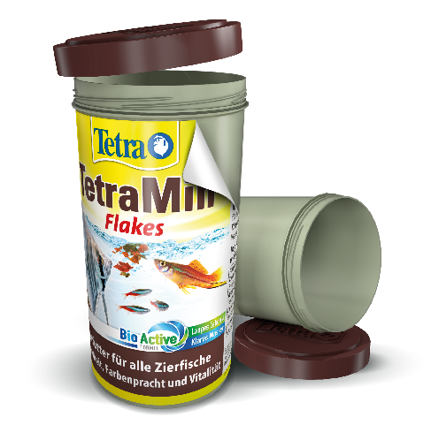
Tetra pioneering with sustainable packaging for fish food
Our Tetra brand is proud to announce the launch of new sustainable packaging for their fish food products, including Pond, TetraMin, Repto and Goldfish. The 500ml and 1l tins aremade of 100% post-industrial recyclate (“PIR”), fully recyclable and not just a novelty for Tetra, but also for the aquatic industry.
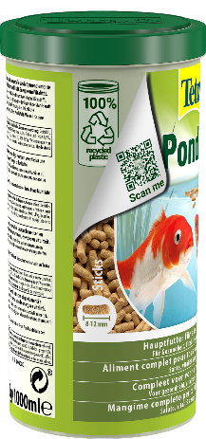
“This was a joint effort between our own teams and our long-term partner in packaging, SPIES”, said Janina Garving, Senior Brand Manager at Tetra. “By reusing the raw material, we are able to save up to 85 tons of plastic per year while continuing to provide high-quality products in functional packaging. It’s another great milestone on our sustainability journey.”
The new PIR packaging is the first action of the newly founded sustainability council at Tetra. Their aim is to drive, supervise, and control all activities connected to the brand’s approach towards a sustainable future.
Tetra's new sustainable fish food packaging is already available in European stores.

