PRODUCT SPECIFICATION
O FSSC 22000
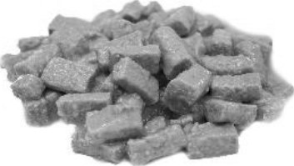
PRODUCT DESCRIPTIONCOMPLETE WET PET FOOD FOR ADULT DOGS WITH POULTRY, CHUNKS IN GRAVY.
PRODUCT WEIGHT415 g/ 1240 g in can
COMPOSITIONmeat and animal derivatives (including 4% poultry), cereals, derivatives of vegetable origin, minerals.
ANALYTICAL CONSTITUENTSMoisture 81%,
Crude protein 6%,
Crude fat 3%,
Crude ash 2%,
Crude fibre 0,5%
ADDITIVES:Vitamin A 1100 IU*, Vitamin m 150 W, Vitamin E 10 mg,
NUTRITIONAL ADDITIVESZinc (zinc oxid) 10 mg, Manganese (manganese oxide) 2 mg,
Copper (copper sulphate pentahydrate) 1,4 mg. (IU International Unit)

TECHNOLOGICAL ADDITIVESantioxidants
TOLERANCESCommission Regulation (EU) 2017/2279 of amending Regulation (EC) No 767/2009 ofthe European Parliament and of the Council on the placing on the market and use of feed
Appearence: colour of the chunk can range between light pink ORGANOLEPTIC PROPERTIESand dark brown. The sauce is smooth, even, lump and crumb free. It must not be discolored.
Scent: specific to the product. Foreign or spoiled scent is not allowed.
Flavour: specific to the product. Foreign or spoiled flavour is not allowed.
Texture: the chuck is a fine textured, columnar piece, extrudated from meaty emulsion. It must not contain foreign substances.
MICROBIOLOGICALThe product corresponds to the requirements of the 65/2012 PARAMETERSregulation.
1/2
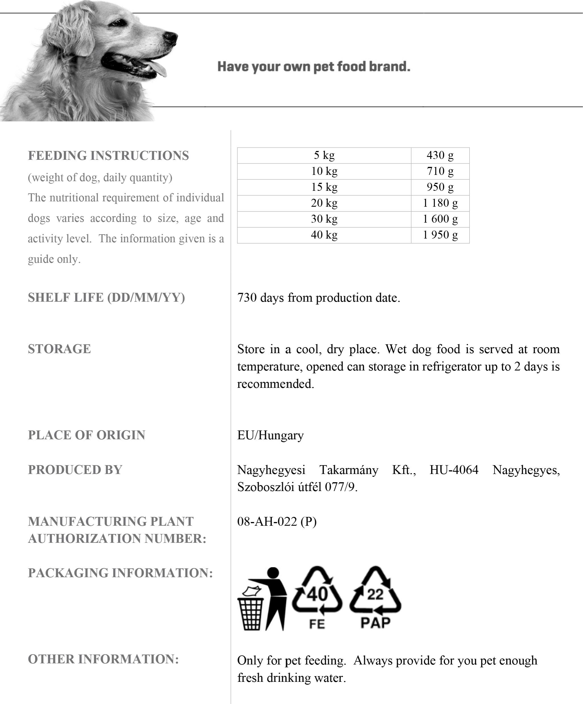
DATE:
24.10.2022
VALID
UNTIL
RECALLED
Made
by:
Jånosné
Baråti
The values mentioned in this product specification are nutritional values. For specific packaging declarations, we refer to the different national legislations. Nagyhegyesi Takarmany cannot be held responsible for the packaging declaration by the private label owner/holder.
2/2

