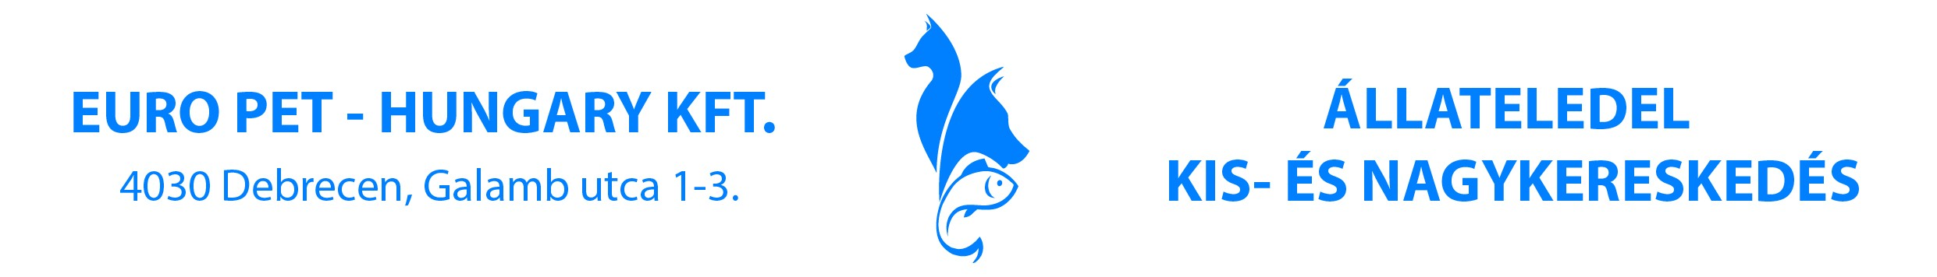
PRODUCT SPECIFICATION 
EURO DOG
5 kg | 105 g
10 kg | 205 g
25 kg | 365 g
45 kg | 570 g
70 kg | 790 g
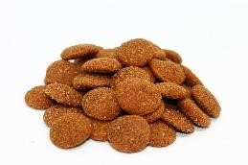
PRODUCT DESCRIPTION Complete dry food for adult dogs with beef
PRODUCT NET WEIGHT 3 kg / 10 kg
COMPOSITION cereals, derivatives of vegetable origin, meat and animal
derivatives (beef 4%), minerals
ANALYTICAL CONSTITUENTS dry matter: 90%
crude protein: 18% crude ash: 7% crude oils and fats: 6%
crude fibre: 4%
NUTRITIONAL ADDITIVES / kg Vitamin A: 4000 IU
Vitamin D3: 450 IU
Vitamin E: 35 mg
OTHER ADDITIVES antioxidants
preservatives
MICROBIOLOGICAL FACTS According to 65/2012. (VII.4.) VM regulation
SENSE FACTS Brown colour, dry consistence, specific smell and taste
FEEDING INSTRUCTIONS
The nutritional requirement of individual dogs varies according to size, age and activity level. The information given is a guide only (weight of dog, daily quantity).
SHELF LIFE 365 days from production date
Store in a cool, dry place. Only for pet feeding.
PLACE OF ORIGIN EU/Hungary
PLANT REG. NUMBER HU08100060
The values mentioned in this product specification are nutritional values. For specific packaging declarations, we refer to the different national legislations. Nagyhegyesi Takarmany Kft. cannot be held responsible for the packaging declaration by the private label owner/holder.
02.12.2019

