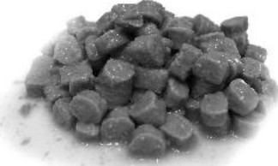
PRODUCT DESCRIPTIONCOMPLETE WET PET FOOD FOR ADULT CATS WITH POULTRY, CHUNKS IN GRAVY.

PRODUCT NET WEIGHT415 g in can
COMPOSITIONmeat and animal derivatives (including 4% poultry), cereals, derivatives of vegetable origin, minerals.
ANALYTICAL CONSTITUENTSMoisture 81%,
Crude protein 6%,
Crude fat 3%,
Crude ash 2%,
Crude fibre 0,5%
PRODUCT SPECIFICATION | O FSSC 22000

ADDITIVES:Vitamin A 1100 IU*, Vitamin m 140 W, Vitamin E 15 mg, NUTRITIONAL ADDITIVESZinc (zinc oxid) 10 mg, Manganese (manganese oxide) 2,5 mg. (IU International Unit)

TECHNOLOGICAL ADDITIVESantioxidants
TOLERANCESCommission Regulation (EU) 2017/2279 of amending Regulation (EC) No 767/2009 of the European Parliament and of the Council on the placing on the market and use of feed
ORGANOLEPTIC PROPERTIESAppearence: colour of the chunk can range between light pink and dark brown. The sauce is smooth, even, lump and crumb free. It must not be discolored.
Scent: specific to the product. Foreign or spoiled scent is not allowed.
Flavour: specific to the product. Foreign or spoiled flavour is not allowed.
Texture: the chuck is a fine textured, columnar piece, extrudated from meaty emulsion. It must not contain foreign substances.

MICROBIOLOGICAL PARAMETERS
The product corresponds to the requirements of the 65/2012
regulation.

VALID UNTIL RECALLED
Made by: Jånosné Baråti
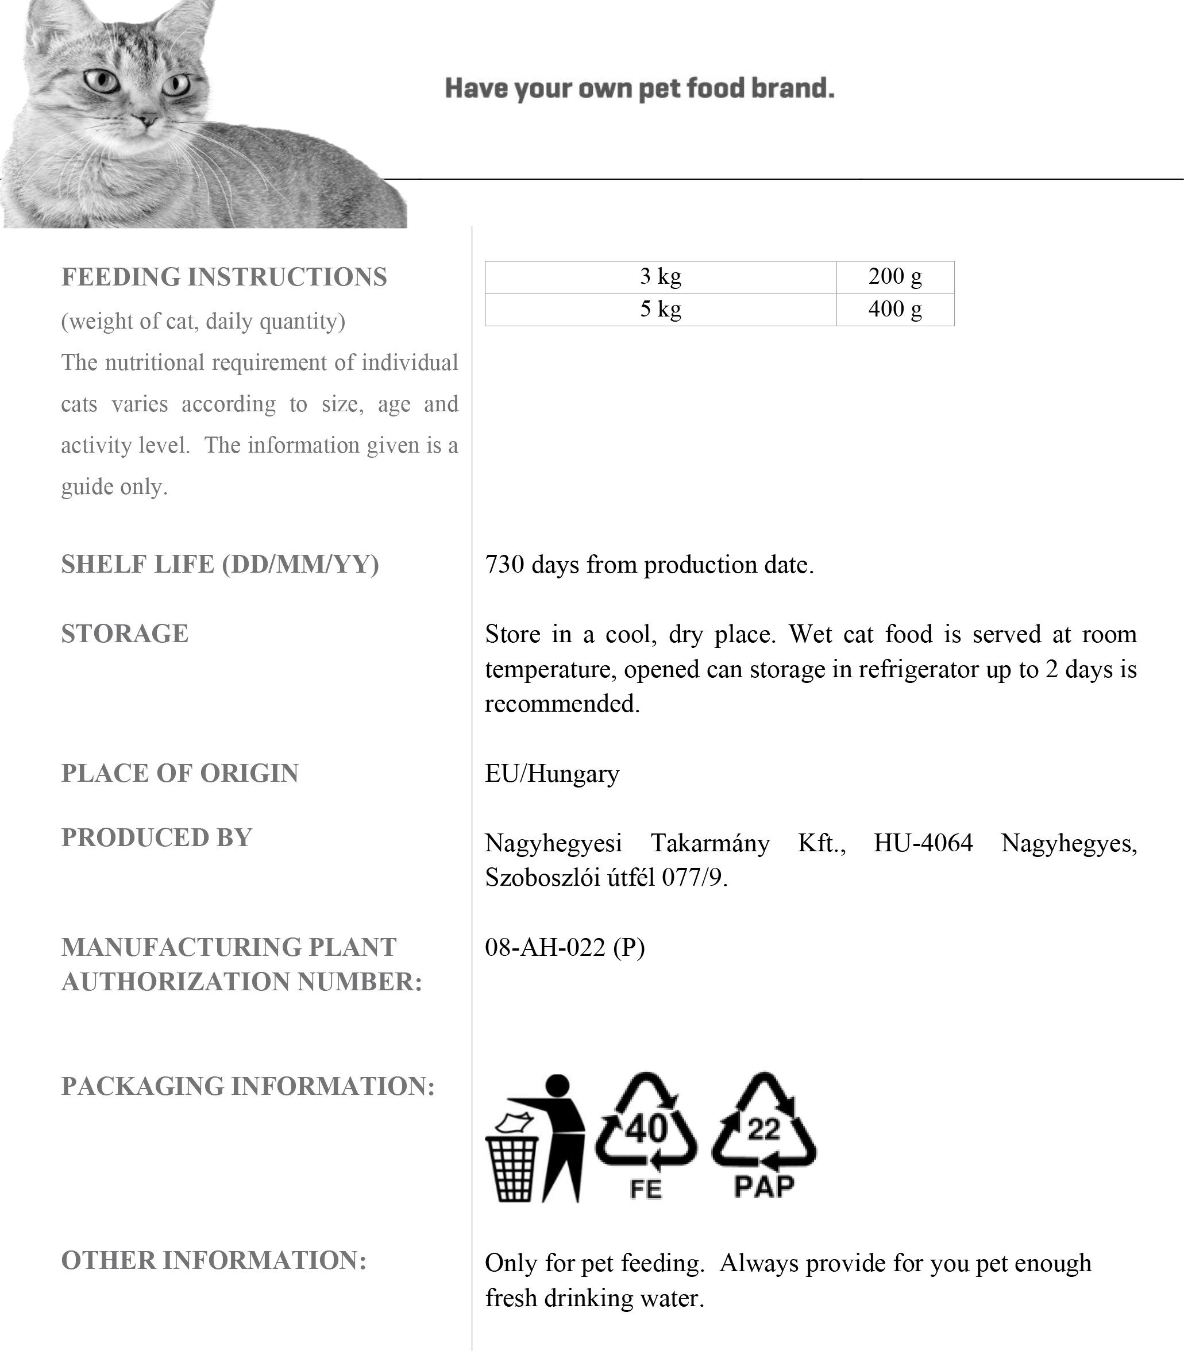
The values mentioned in this product specification are nutritional values. For specific packaging declarations, we refer to the different national legislations. Nagyhegyesi Takarmany cannot be held responsible for the packaging declaration by the private label owner/holder.
DATE:
24.10.2022

