Product name: Carnilove Fresh Chicken & Rabbit

*** Muscles, Bones & Joints ***

Grain-free & Potato-free Formula with Fresh Meat for Adult Dogs of All Breeds. Complete Dog Food.

Package: 12 kg, 1,5 kg

Composition: fresh chicken deboned (40%), dried rabbit (20%), dried duck (10%), pumpkin, chickpeas, peas, chicken fat (preserved with tocopherols, 5%), chicken liver (3%), salmon oil (2%), apples, carrots, flaxseed, hydrolyzed crustacean shells (a source of glucosamine, 0.026%), cartilage extract (a source of chondroitin, 0.016%), brewer’s yeast (a source of mannan-oligosaccharides, 0.015%), chicory root (a source of fructo-oligosaccharides, 0.01%), yucca schidigera (0.01%), algae (0.01%), psyllium (0.01%), thyme (0.01%), rosemary (0.01%), oregano (0.01%), cranberries (0.0008%), blueberries (0.0008%), sea buckthorn (0.0008%), ginger root (0.0008%), sage (0.0008%)

Feeding guide: Serve dry or moistened with lukewarm water. The recommended daily serving size is shown in the feeding table and may vary depending on your dog’s age, size, activity level, and environment. When serving Carnilove for the first time, use smaller amounts and mix it with the previous food, gradually increasing the proportion of Carnilove. Make sure your dog always has plenty of fresh water.
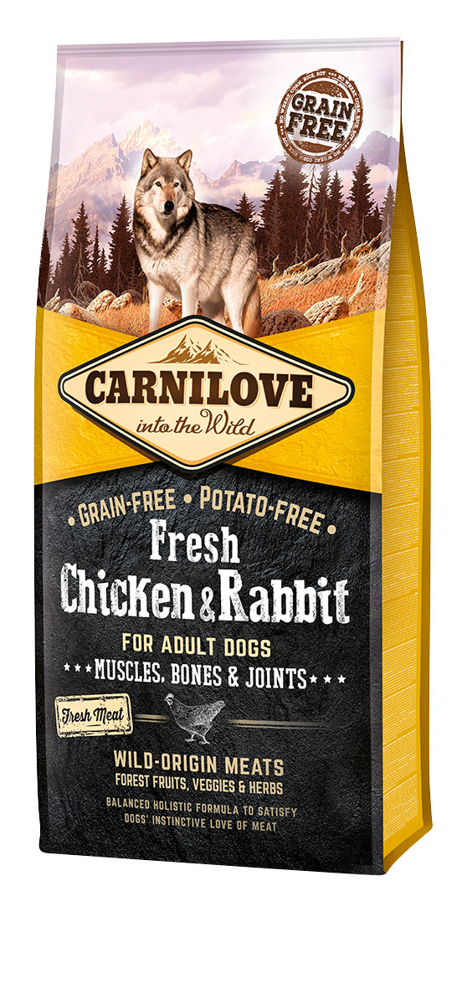
Analytical constituents:
crude protein | 35.0 | %
fat content | 18.0 | %
moisture | 10.0 | %
crude ash | 8.5 | %
crude fibre | 3.5 | %
calcium | 1.4 | %
phosphorus | 1.0 | %
omega-3 | 0.6 | %
omega-6 | 1.7 | %
EPA (20:5 n-3) | 0.08 | %
DHA (22:6 n-3) | 0.1 | %
Nutritional additives per 1 kg:
vitamin A (3a672a) | 20,000 | IU
vitamin D₃ (E671) | 1,500 | IU
vitamin E (α-tocopherol) (3a700) | 400 | mg
zinc (3b606) | 85 | mg
iron (E1) | 70 | mg
manganese (E5) | 35 | mg
iodine (3b201) | 0.65 | mg
copper (E4) | 15 | mg
selenium (3b8.10) | 0.2 | mg

Contains pure natural antioxidants.

Feeding table:
Weight of dog (kg) | 5 | 10 | 15 | 20 | 25 | 30 | 40 | 50 | 60 | 70 | 80 | 90
Daily consumption (g) | 75 | 130 | 170 | 200 | 250 | 280 | 350 | 410 | 470 | 530 | 580 | 640

Metabolizable energy: 3 820 kcal/kg

Best use before date shown on package. Keep in a dry cool place away from direct sunlight.

Producer: VAFO PRAHA s.r.o., K Brůdku 94, 252 19 Chrášťany, Czech Republic, Registration No: CZ 800175-01/02/03, Export No: CZ939

www.carnilove.com

Product name: Carnilove Fresh Ostrich & Lamb for Small-Breed Dogs

***Excellent Digestion***

Grain-free & Potato-free Formula with Fresh Meat for Adult Dogs of Small Breeds. Complete Dog Food.

Package: 6 kg, 1,5 kg

Composition: fresh ostrich deboned (26%), dried lamb (20%), dried turkey (20%), chicken fat (preserved with tocopherols, 9%), pumpkin, chickpeas, peas, chicken liver (3%), salmon oil (2%), apples, carrots, flaxseed, hydrolyzed crustacean shells (a source of glucosamine, 0.026%), cartilage extract (a source of chondroitin, 0.016%), brewer’s yeast (a source of mannan-oligosaccharides, 0.015%), chicory root (a source of fructo-oligosaccharides, 0.01%), yucca schidigera (0.01%), algae (0.01%), psyllium (0.01%), thyme (0.01%), rosemary (0.01%), oregano (0.01%), cranberries (0.0008%), blueberries (0.0008%), sea buckthorn (0.0008%), ginger root (0.0008%), sage (0.0008%)

Feeding guide: Serve dry or moistened with lukewarm water. The recommended daily serving size is shown in the feeding table and may vary depending on your dog’s age, size, activity level, and environment. When serving Carnilove for first time, use smaller amounts and mix it with the previous food, gradually increasing the proportion of Carnilove. Make sure your dog always has plenty of fresh water.

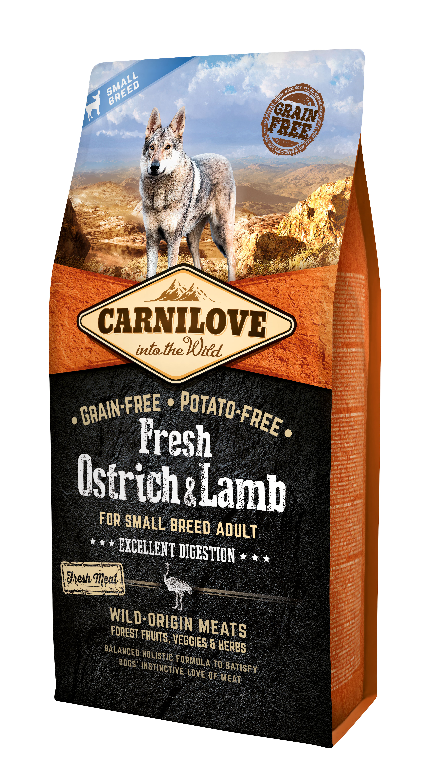
Analytical constituents:
crude protein | 30.0 | %
fat content | 17.0 | %
moisture | 10.0 | %
crude ash | 8.2 | %
crude fibre | 3.5 | %
calcium | 1.6 | %
phosphorus | 1.3 | %
omega-3 | 0.6 | %
omega-6 | 1.8 | %
EPA (20:5 n-3) | 0.08 | %
DHA (22:6 n-3) | 0.1 | %
Nutritional additives per 1 kg:
vitamin A (3a672a) | 20,000 | IU
vitamin D₃ (E671) | 1,500 | IU
vitamin E (α-tocopherol) (3a700) | 400 | mg
zinc (3b606) | 85 | mg
iron (E1) | 70 | mg
manganese (E5) | 35 | mg
iodine (3b201) | 0.65 | mg
copper (E4) | 15 | mg
selenium (3b8.10) | 0.2 | mg
Contains pure natural antioxidants.

Feeding table:
Weight of dog (kg) | 1 | 2 | 4 | 6 | 8 | 10
Daily consumption (g) | 30 | 40 | 55 | 75 | 110 | 130

Metabolizable energy: 3 770 kcal/kg

Best use before date shown on package. Keep in a dry cool place away from direct sunlight.

Producer: VAFO PRAHA s.r.o., K Brůdku 94, 252 19 Chrášťany, Czech Republic, Registration No: CZ 800175-01/02/03, Export No: CZ939

www.carnilove.com

Product name: Carnilove Fresh Carp & Trout

***Shiny Hair & Healthy Skin***

Grain-free & Potato-free Formula with Fresh Meat for Adult Dogs of All Breeds. Complete Dog Food.

Package: 12 kg, 1,5 kg

Composition: fresh carp deboned (26%), dried trout (18%), fresh salmon deboned (14%), dried salmon (12%), pumpkin, chickpeas, peas, chicken fat (preserved with tocopherols, 5%), chicken liver (3%), salmon oil (2%), apples, carrots, flaxseed, hydrolyzed crustacean shells (a source of glucosamine, 0.026%), cartilage extract (a source of chondroitin, 0.016%), brewer’s yeast (a source of mannan-oligosaccharides, 0.015%), chicory root (a source of fructo-oligosaccharides, 0.01%), yucca schidigera (0.01%), algae (0.01%), psyllium (0.01%), thyme (0.01%), rosemary (0.01%), oregano (0.01%), cranberries (0.0008%), blueberries (0.0008%), sea buckthorn (0.0008%), ginger root (0.0008%), sage (0.0008%)

Feeding guide: Serve dry or moistened with lukewarm water. The recommended daily serving size is shown in the feeding table and may vary depending on your dog’s age, size, activity level, and environment. When serving Carnilove for first time, use smaller amounts and mix it with the previous food, gradually increasing the proportion of Carnilove. Make sure your dog always has plenty of fresh water.

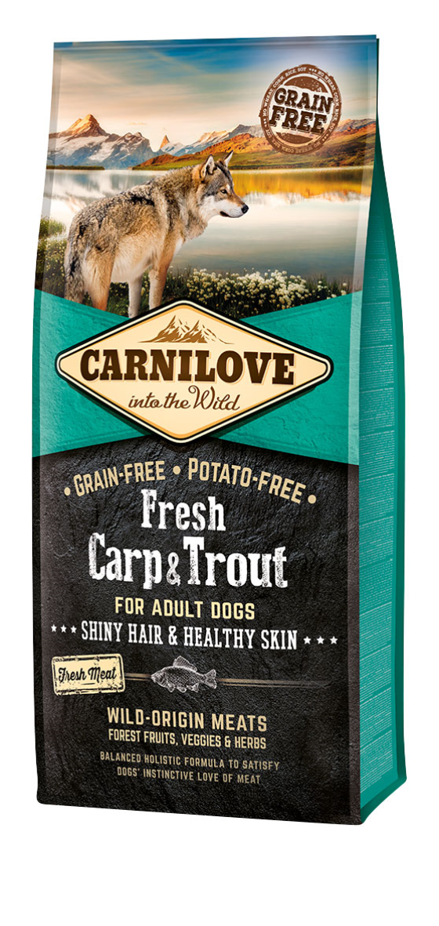
Analytical constituents:
crude protein | 34.0 | %
fat content | 15.0 | %
moisture | 10.0 | %
crude ash | 7.2 | %
crude fibre | 3.5 | %
calcium | 1.0 | %
phosphorus | 0.8 | %
omega-3 | 0.8 | %
omega-6 | 1.8 | %
EPA (20:5 n-3) | 0.1 | %
DHA (22:6 n-3) | 0.2 | %
Nutritional additives per 1 kg:
vitamin A (3a672a) | 20,000 | IU
vitamin D₃ (E671) | 1,500 | IU
vitamin E (α-tocopherol) (3a700) | 400 | mg
zinc (3b606) | 85 | mg
iron (E1) | 70 | mg
manganese (E5) | 35 | mg
iodine (3b201) | 0.65 | mg
copper (E4) | 15 | mg
selenium (3b8.10) | 0.2 | mg
Contains pure natural antioxidants.

Feeding table:
Weight of dog (kg) | 5 | 10 | 15 | 20 | 25 | 30 | 40 | 50 | 60 | 70 | 80 | 90
Daily consumption (g) | 75 | 130 | 170 | 220 | 250 | 290 | 360 | 420 | 480 | 540 | 600 | 660

Metabolizable energy: 3 730 kcal/kg

Best use before date shown on package. Keep in a dry cool place away from direct sunlight.

Producer: VAFO PRAHA s.r.o., K Brůdku 94, 252 19 Chrášťany, Czech Republic, Registration No: CZ 800175-01/02/03, Export No: CZ939

www.carnilove.com

