HYPOALLERGENIC
Dietetic Complete Feed for dogs - reduction of ingredient and nutrient intolerances.

INDICATIONS
- Food allergies with dermatological or gastrointestinal symptoms
- Food intolerance
- Otitis externa, atopic dermatitis
- Support of health and quality of hair and skin
- Frequent diarrhea and bowel infections
- Soothing of digestive tract
- Long-term nutrition following elimination diet

BENEFITS

GRAIN-FREE
low glycemic index, optimal digestion, lowers risk of allergic reaction

SINGLE PROTEIN SOURCE
tasty salmon, dehydrated – highly digestible source of protein

HYDROLYSED SALMON PROTEIN
highly digestible and unlikely to cause allergies - under 5 000 Da

HIGH CONTENT OF OMEGA-3 (1.2%)
support of healthy skin and coat

BIOTIN 3.5 MG / ZINC 150 MG / VITAMIN C 600 MG
skin barrier support, healing effect

YELLOW PEAS / BUCKWHEAT
gluten-free, low allergenic properties, high digestibility

KELP (ASCOPHYLLUM NODOSUM)
natural source of I2 / K + aminoacids, source of prebiotic fibre for balanced intestinal microflora

SOY-FREE
limitation of anti-nutritional compounds, such as phytates and phytoestrogens, which disrupt hormone levels, elimination of allergies

SEA BUCKTHORN
antioxidant properties, immune stimulation

SCHIZOCHYTRIUM LIMACINUM
concentrated source of DHA
- SALMON WITH PEA
- SALMON, PEA & BUCKWHEAT

FEEDING TABLE:
WEIGHT OF THE DOG (KG) | 5-10 | 10-30 | 30-60
DAILY DOSE (G) | 200 - 400 | 400 – 1 000 | 1 000 – 1 600

COMPOSITION:
salmon (55%), green peas (4%), salmon oil (3%), pea flour, lignocellulose, calcium carbonate, dried algae (0.5%, Schizochytrium limacinum), dried algae (0.5%, Ascophyllum nodosum), mannan-oligosaccharides (0.005%), β-glucans (0.005%), fructo-oligosaccharides (0.004%), Mojave yucca (0.003%), dried sea buckthorn (0.003%).

METABOLISABLE ENERGY:
1 150 kcal/kg

ANALYTICAL CONSTITUENTS:
crude protein 8.0 %, fat content 8.0 %, crude ash 2.5 %, moisture 78.0 %, crude fibre 1.0 %, calcium 0.2 %, phosphorus 0.3 %, sodium 0.25 %, EPA (20:5 n-3) 0.01 %, DHA (22:6 n-3) 0.15 %, magnesium 0.1 %, omega 3 0.3 %, omega 6 0.2 %

NUTRITIONAL ADDITIVES PER 1 KG:
vitamin A (3a672a) 5,000 I.U., vitamin D3 (3a671) 400 I.U., vitamin E (3a700) 200 mg, vitamin C (3a312) 150 mg, biotin (3a880) 0.8 mg, zinc (3b606) 35 mg, iron (3b106) 20 mg, manganese (3b504) 12 mg, potassium iodide (3b201) 0.2 mg, copper (3b406) 5 mg, selenium (3b8.10) 0.05 mg. Technological additives per 1 kg: carob gum (E 410) 5,000 mg.
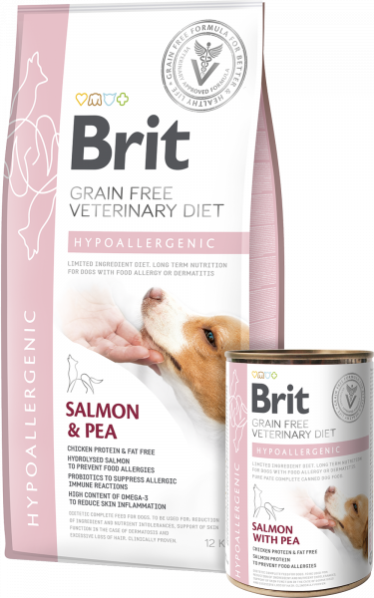
0.4 kg
12 kg & 2 kg

STRUVITE
Dietetic Complete Feed for dogs - dissolution of struvite stones, reduction of struvite stone recurrence

INDICATIONS
- Dissolution of struvite stones
- Prevention of struvite stones recurrence
- Urinary tract diseases
- Urinary tract bacterial infections

BENEFITS

GRAIN-FREE
low glycemic index

CALCIUM SULPHATE / L-METHIONINE / SODIUM CHLORIDE
accelerates dissolution of struvite stones, pH control

L-TRYPTOPHAN
calming effect

SODIUM CHLORIDE
dilutes urine, limits formation of struvite / oxalate stones

LOW MAGNESIUM 0.05%
eliminates the reformation of struvite stones

HIGH OMEGA-3 CONTENT
High omega-3 content 0.7%

ANTIOXIDANTS
Antioxidants A, C, E

YELLOW PEAS / BUCKWHEAT
gluten-free, high digestibility

KELP (ASCOPHYLLUM NODOSUM)
natural source of I2 / K + aminoacids, source of prebiotic fibre for balanced intestinal microflora

SEA BUCKTHORN
antioxidant properties, immune stimulation, anti-inflammatory action, wound healing properties

VACCINIUM VITIS-IDAEA
cranberries, urinary tract support
- TURKEY WITH PEA
- EGGS & TURKEY, PEA & BUCKWHEAT

FEEDING TABLE:
WEIGHT OF THE DOG (KG) | 5-10 | 10-30 | 30-60
DAILY DOSE (G) | 200 - 400 | 400 - 900 | 900 - 1500

COMPOSITION:
turkey (55%), green peas (4%), salmon oil (2%), pea flour, lignocellulose, calcium carbonate, dried algae (0.5%, Ascophyllum nodosum), sodium chloride (0.5%), calcium sulphate (0.25%, urine acidifying substance), dried cranberries (0.2%, Vaccinium vitis-idaea), mannan-oligosaccharides (0.004%), fructo-oligosaccharides (0.003%), Mojave yucca (0.003%), β-glucans (0.003%), dried sea buckthorn (0.003%).

METABOLISABLE ENERGY:
1 060 kcal/kg

ANALYTICAL CONSTITUENTS:
crude protein 8.0 %, fat content 7.0 %, crude ash 3.0 %, moisture 78.0 %, crude fibre 1.0 %, calcium 0.2 %, phosphorus 0.2 %, sodium 0.8 %, magnesium 0.04 %, potassium 0.3 %, chlorides 0.35 %, sulphur 0.1 %, hydroxyproline 0.1 %, vitamin D 200 IU/kg, omega 3 0.2 %, omega 6 0.3 %

NUTRITIONAL ADDITIVES PER 1 KG:
vitamin A (3a672a) 5,000 I.U., vitamin D3 (3a671) 200 I.U., vitamin E (3a700) 200 mg, biotin (3a880) 0.5 mg, zinc (3b606) 30 mg, iron (3b106) 15 mg, manganese (3b504) 18 mg, potassium iodide (3b201) 0.9 mg, copper (3b406) 1.0 mg, selenium (3b8.10) 0.05 mg, L-carnitine (3a910) 80 mg, L-methionine (3c305) 4,000 mg, L- tryptophan (3c440) 250 mg, Technological additives per 1 kg: carob gum (E 410) 5,000 mg
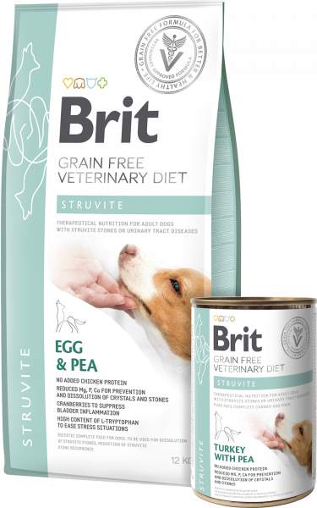
0.4 kg
12 kg & 2 kg

RENAL
Dietetic Complete Feed for dogs – support of renal function in case of chronic renal insufficiency

INDICATIONS
- Chronic renal insufficiency

CONTRAINDICATIONS
- Puppies
- Pregnant and nursing dogs

BENEFITS

TASTY EGGS / HYDROLYSED SALMON PROTEIN
highly digestible source of protein

HIGHER FAT CONTENT 17%
higher energy content 3,880 kcal/kg

POTASSIUM CITRATE / ARGININE
Potassium citrate 8,000 mg / arginine 4,200 mg

LOW PROTEIN / PHOSPHORUS CONTENT
Low protein content 14% / low phosphorus

YELLOW PEAS / BUCKWHEAT
gluten-free, high digestibility

KELP (ASCOPHYLLUM NODOSUM)
natural source of I2 / K + aminoacids, source of prebiotic fibre for balanced intestinal microflora

CHITOSAN
phosphorus binding, renal function support

MOS / FOS / Β-GLUCANS
prebiotics for optimal intestinal microflora

PSYLLIUM
water-soluble fibre source, intestinal scrubbing and support

SEA BUCKTHORN
antioxidant properties, immune stimulation
- TUNA WITH PEA
- EGGS, PEA & BUCKWHEAT

FEEDING TABLE:
WEIGHT OF THE DOG (KG) | 5-10 | 10-30 | 30-60
DAILY DOSE (G) | 200 - 400 | 400 - 900 | 900 - 1500

COMPOSITION:
tuna (35%), salmon (20%), green peas (4%), salmon oil (2%), pea flour, lignocellulose, calcium carbonate, potassium citrate (0.5%), dried algae (0.5%, Ascophyllum nodosum), dried algae (0.4%, Schizochytrium limacinum), chitosan (0.02%), mannan-oligosaccharides (0.005%), fructo-oligosaccharides (0.005%), Mojave yucca (0.004%), β-glucans (0.004%), dried sea buckthorn (0.003%).

METABOLISABLE ENERGY:
1 120 kcal/kg

ANALYTICAL CONSTITUENTS:
crude protein 7.0 %, fat content 7.5 %, crude ash 2.0 %, moisture 78.0 %, crude fibre 1.0 %, calcium 0.1 %, phosphorus 0.1 %, sodium 0.2 %, magnesium 0.02 %, potassium 0.3 %, arginine 0.15 %, taurine 0.1 %, omega 3 0.3 %, omega 6 0.2 %

NUTRITIONAL ADDITIVES PER 1 KG:
vitamin A (3a672a) 5,000 I.U., vitamin D3 (3a671) 200 I.U., vitamin E (3a700) 150 mg, vitamin C (3a312) 100 mg, biotin (3a880) 0.5 mg, zinc (3b606) 30 mg, iron (3b106) 15 mg, manganese (3b504) 15 mg, potassium iodide (3b201) 0.8 mg, copper (3b406) 1.0 mg, selenium (3b8.10) 0.05 mg, taurine (3a370) 500 mg, L-cartinine (3a910) 80 mg, L-arginine (3c3.6.1.) 700 mg. Technological additives per 1 kg: carob gum (E 410) 5,000 mg.
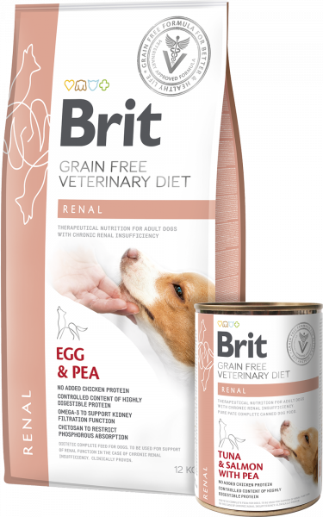
0.4 kg
2 kg & 12 kg

DIABETES
Dietetic Complete Feed for dogs - regulation of glucose supply (Diabetes mellitus)

INDICATIONS
- Diabetes mellitus
- Maintenance of optimal weight
- Added fibre for satiety

CONTRAINDICATIONS
- Puppies
- Pregnant and nursing dogs

BENEFITS

GRAIN-FREE
low glycemic index, lowers the risk of postprandial hyperglycemia

TASTY TURKEY DEHYDRATED
high-quality and digestible source of protein

HIGH PROTEIN CONTENT 37%
muscle mass and weight maintenance

LOW SIMPLE SUGARS CONTENT 1.5% / STARCH 16%
positive impact on blood glucose levels

ANTIOXIDANTS A, C, E
lessen the effects of oxidative stress

PSYLLIUM SEEDS
water-soluble source of fibre, intestinal scrubbing, improved weight loss

YELLOW PEAS / BUCKWHEAT
gluten-free, hypoallergenic properties, high digestibility

KELP (ASCOPHYLLUM NODOSUM)
natural source of I2 / K + aminoacids, source of prebiotic fibre for balanced intestinal microflora

CHONDROPROTECTIVES
promote joint cartilage health

SEA BUCKTHORN
antioxidant properties, immune stimulation, healing properties
- TURKEY AND PEA
- LAMB WITH PEA

METHOD OF USE:
INITIAL FEEDING PERIOD:
Use Brit VD Diabetes Dog initially for a period of up to 6 months. The daily amount of food should be divided into 3 equal portions and served at regular intervals depending on your dog’s medical condition. Regular checks of blood glucose are essential to obtaining the optimal insulin dose. Don´t feed your dog any other pet food or human food and snacks.
LONG-TERM FEEDING:
Maintenance of optimal weight for dogs with diabetes mellitus improves sensitivity to insulin. Regular checks of body weight are essential to the effective management of diabetes mellitus.

FEEDING TABLE:
DOG WEIGHT (KG) | 2 | 5 | 10 | 15 | 20 | 25 | 30 | 40 | 50 | 60 | 70 | 80
DAILY AMOUNT (G) | 35 | 85 | 140 | 190 | 230 | 280 | 320 | 400 | 460 | 530 | 600 | 660

COMPOSITION:
dehydrated turkey (30%), yellow peas (18%), hydrolyzed turkey protein (14%), dried apples, yellow pea protein, bamboo lignocellulose (5%), chicken fat (3%), salmon oil (2%), hydrolysed chicken liver (2%), minerals, psyllium husks and seeds (0.5%), dried algae (0.5%, Ascophyllum nodosum), sodium chloride, hydrolysed crustacean shells (a source of glucosamine sulphate, 0.035%), hydrolysed cartilage (a source of chondroitin sulphate, 0.023%), yeast extract (source of mannan-oligosaccharides, 0.018%), β-glucans (0.018%), sea buckthorn (0.015%), fructo-oligosaccharides (0.012%), Mojave yucca (0.012%).

METABOLISABLE ENERGY:
3,390 kcal/kg

ANALYTICAL CONSTITUENTS:
crude protein 37.0 %, fat content 12.0 %, crude fibre 6.5 %, crude ash 7.5 %, moisture 10 %, omega-3 0.5 %, omega-6 1.35 %, calcium 1.64 %, phosphorus 1.2 %, sodium 0.35 %, magnesium 0.08 %, starch 16 %, total sugars 1.5 %

NUTRITIONAL ADDITIVES PER 1 KG:
vitamin A (3a672a) 20,000 I.U., vitamin D3 (E671) 1,000 I.U., vitamin E (3a700) 1,000 mg, vitamin C (3a312) 500 mg, choline chloride (3a890) 2,300 mg, biotin (3a880) 2.4 mg, vitamin B1 (3a821) 11 mg, vitamin B2 10 mg,
niacinamide (3a315) 55 mg, calcium-D-panthothenate (3a841) 25 mg, vitamin B6 (3a831) 7 mg, folic acid (3a316) 5 mg, vitamin B12 0.17 mg, zinc chelate of amino acids hydrate (3b606) 140 mg, ferrous chelate of amino acids hydrate (E1) 45 mg, manganese chelate of amino acids hydrate (E5) 60 mg, potassium iodide (3b201) 3.5 mg, cupric chelate of amino acids hydrate (E4) 5 mg, organic form of Selenium produced by Saccaromyces cerevisiae CNCM I-3060 (selenised yeast inactivated) (3b8.10) 0.2 mg, taurine (3a370) 2,300 mg, L-carnitine (3a910) 500 mg. Gut flora stabilisers per 1 kg: Enterococcus faecium DSM 10663/NCIMB 10415 (4b1707) 1x109 CFU

Contains EU approved antioxidants: tocopherol extracts from vegetable oil (1b306), ascorbyl palmitate (1b304) & rosemary extract.
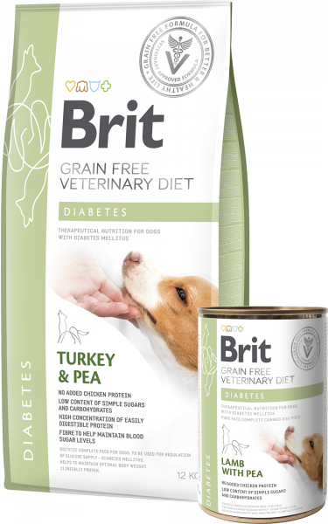
2 kg & 12 kg
0.4 kg

OBESITY
Dietetic Complete Feed for dogs – reduction of excessive body weight

INDICATIONS
- Obesity and excess weight
- Tendency to gain weight following castration

CONTRAINDICATIONS
- Puppies
- Pregnant and nursing dogs

BENEFITS

GRAIN-FREE
low glycemic index, prevents weight gain

TASTY LAMB, DEHYDRATED
highly digestible dietetic source of protein

HIGH-QUALITY PROTEIN CONTENT 35%
muscle mass maintenance

HIGH FIBRE CONTENT WITH L-CARNITINE 630 MG
facilitates weight loss

PSYLLIUM SEEDS
water-soluble fibre source, intestinal scrubbing, improved weight loss

YELLOW PEAS / BUCKWHEAT
gluten-free, high digestibility

KELP (ASCOPHYLLUM NODOSUM)
natural source of I2 / K + aminoacids, source of prebiotic fibre for balanced intestinal microflora

CHONDROPROTECTIVES
promote joint cartilage health

SEA BUCKTHORN
antioxidant properties, immune stimulation
- LAMB WITH PEA
- LAMB, TURKEY & PEA

FEEDING TABLE:
WEIGHT OF THE DOG (KG) | 5-10 | 10-30 | 30-60
DAILY DOSE (G) | 300 - 500 | 500 – 1 200 | 1 200 – 2 000

COMPOSITION:
lamb (55%), green peas (4%), salmon oil (2%), lignocellulose (2%), pea flour, calcium carbonate, psyllium husks and seeds (0.5%), dried algae (0.5%, Ascophyllum nodosum), glucosamine (0.018%), chondroitin sulphate (0.013%), mannan-oligosaccharides (0.01%), β-glucans (0.01%), fructo-oligosaccharides (0.008%), Mojave yucca (0.006%), dried sea buckthorn (0.008%).

METABOLISABLE ENERGY:
1 030 kcal/kg

ANALYTICAL CONSTITUENTS:
crude protein 8.0 %, fat content 7.0 %, crude ash 2.0 %, moisture 78.0 %, total sugars (as NFE) 2.5 %, crude fibre 4.5 %, calcium 0.1 %, phosphorus 0.2 %, sodium 0.1 %, starch 2.0 %, total sugars 1.0 %, magnesium 0.08 %, omega 3 0.1 %, omega 6 0.2 %

NUTRITIONAL ADDITIVES PER 1 KG:
vitamin A (3a672a) 5,000 I.U., vitamin D3 (3a671) 300 I.U., vitamin E (3a700) 300 mg, vitamin C (3a312) 150 mg, biotin (3a880) 0.6 mg, zinc (3b606) 40 mg, iron (3b106) 15 mg, manganese (3b504) 15 mg, potassium iodide (3b201) 1.0 mg, copper (3b406) 1.5 mg, selenium (3b8.10) 0.05 mg, taurine (3a370) 600 mg, L-cartinine (3a910) 200 mg. Technological additives per 1 kg: carob gum (E 410) 5,000 mg
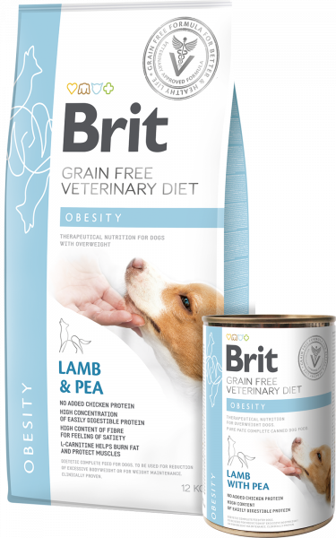
0.4 kg
12 kg & 2 kg

GASTROINTESTINAL
Dietetic Complete Feed for dogs – reduction of acute intestinal absorptive disorders, compensation of maldigestion

INDICATIONS
- Gastrointestinal disorders (diarrhoea, vomiting)
- Soothing of the digestive tract after diarrhoea or vomiting
- Pancreatitis
- Increased flatulence
- Digestive disorders
- Exocrine pancreatic insufficiency (EPI)

BENEFITS

GRAIN-FREE
low glycemic index, soothes the digestive tract

TASTY HERRING, DEHYDRATED / HYDROLYSED SALMON PROTEIN / EGGS
highly digestible sources of protein

PROTEIN AND FAT
more energy in smaller quantity of food

YELLOW PEAS / BUCKWHEAT
gluten-free, high digestibility

HIGH OMEGA-3 CONTENT (0.85%)
support the optimal condition of intestine

KELP (ASCOPHYLLUM NODOSUM)
natural source of I2 / K + aminoacids, source of prebiotic fibre for balanced intestinal microflora

BREWER’S YEAST
prebiotic properties, prevention of digestive problems

HIGH IN MOS / FOS / Β-GLUCANS
prebiotics for optimal intestinal microflora

SEA BUCKTHORN
antioxidant properties, immune stimulation
- HERRING, SALMON, PEA & BUCKWHEAT
- SALMON WITH PEA

METHOD OF USE:
ACUTE GASTROINTESTINAL PROBLEMS:
In case of acute intestinal absorption disorders feed only Brit VD Gastrointestinal Dog and water for 1–3 weeks. Intestinal will need up to 3 weeks for full regeneration and function restoration.
CHRONIC GASTROINTESTINAL PROBLEMS:
In case of maldigestion, use Brit VD Gastrointestinal Dog for a period of 3–12 weeks. In case of chronic gastrointestinal problems the food should be used for life.

FEEDING TABLE:
DOG WEIGHT (KG) | 2 | 5 | 10 | 15 | 20 | 25 | 30 | 40 | 50 | 60 | 70 | 80
DAILY AMOUNT (G) | 30 | 70 | 120 | 160 | 200 | 240 | 270 | 340 | 400 | 460 | 510 | 570

COMPOSITION:
dehydrated herring (26%), yellow peas (23%), buckwheat, hydrolysed salmon protein (12%), chicken fat (10%), apple pulp, eggs (2%), salmon oil (2%), hydrolysed salmon gravy (2%), brewer’s yeast (1%), minerals, psyllium husks and seeds (0.5%), dried algae (0.5%, Ascophyllum nodosum), egg shells (a source of calcium), yeast extract (source of mannan-oligosaccharides, 0.025%), β-glucans (0.022%), fructo-oligosaccharides (0.02%), Mojave yucca (0.02%), sea buckthorn (0.015%).

METABOLISABLE ENERGY:
3,930 kcal/kg

ANALYTICAL CONSTITUENTS:
crude protein 25.0 %, fat content 16.0 %, crude fibers 1.5 %, crude ash 5.8 %, moisture 10 %, omega 3 0.85 %, omega 6 2.2 %, calcium 0.9 %, phosphorus 0.6 %, sodium 0.5 %, magnesium 0.09 %, potassium 0.5 %

NUTRITIONAL ADDITIVES PER 1 KG:
vitamin A (3a672a) 22,000 I.U., vitamin D3 (E671) 1,000 I.U., vitamin E (3a700) 1,000 mg, vitamin C (3a312) 500 mg, choline chloride (3a890) 2,300 mg, biotin (3a880) 2.4 mg, vitamin B1 (3a821) 11 mg, vitamin B2 14 mg, niacinamide (3a315) 94 mg calcium-D-panthothenate (3a841) 25 mg, vitamin B6 (3a831) 7 mg, folic acid (3a316) 2.4 mg, vitamin B12 0.16 mg, zinc chelate of amino acids hydrate (3b606) 140 mg, ferrous chelate of amino acids hydrate (E1) 65 mg, manganese chelate if amino acids hydrate (E5) 75 mg, potassium iodide (3b201) 4.2 mg, cupric chelate of amino acids hydrate (E4) 5 mg, organic form of Selenium produced by Saccaromyces cerevisiae CNCM I-3060 (selenised yeast inactivated) (3b8.10) 0.2 mg, L-carnitine (3a910) 350
mg. Gut flora stabilisers per 1 kg: Enterococcus faecium DSM 10663/NCIMB 10415 (4b1707) 1x109 CFU

Contains EU approved antioxidants: tocopherol extracts from vegetable oil (1b306), ascorbyl palmitate (1b304) & rosemary extract.
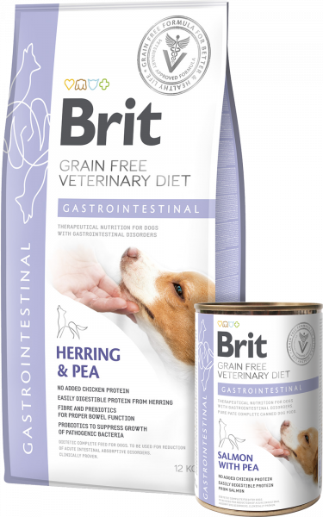
2 kg & 12 kg
0.4 kg

ULTRA-HYPOALLERGENIC
Complete and balanced hypoallergenic dietetic dog foodwith insect protein for reduction of food intolerances

INDICATIONS
- Mitigation of skin and digestive symptoms caused by food allergies
- Reduction of atopic and pruritic dermatological symptoms
- Strengthens the formation of the natural skin barrier and immunity
- Supports the healingof inflammatory skin diseases

BENEFITS
- Low risk of food allergies and intolerance to common proteins
- No risk of allergy/intolerance to gluten or chicken protein
- Strengthening of the natural skin barrier and immunity
- Supports the intestinal microbiome and immune system

COMPOSITION:
dehydrated insect (30%), yellow peas, dried apple pulp, coconut oil, pea protein, linseed (4%), calcium carbonate, dried algae (2.5%, Schizochytrium limacinum), pea flour, hydrolyzed yeasts (0.5% - a source of inositol and amino acids), yeast extract (source of mannan-oligosaccharides, 0.02%), β-glucans (0.02%), dried sea buckthorn (0.015%), fructo-oligosaccharides (0.013%), Mojave yucca (0.013%), Lactobacillus helveticus HA – 122 inactivated (15x109 cells/kg).

METABOLISABLE ENERGY:
3,750 kcal/kg.

ANALYTICAL CONSTITUENTS:
crude protein 26.0 %, crude fat 15.0 %, crude fibre 3.2 %, crude ash 6.2 %, moisture 10.0 %, omega-3 fatty acids 1.5 %, omega-6 fatty acids 1.4%, EPA (20:5 n-3) 0.25 %, DHA (22:6 n-3) 0.35 %, LA (18:2 n-6) 2.1 %, calcium 1.1 %, phosphorus 0.7 %, sodium 0.2 %, magnesium 0.1 %.

NUTRITIONAL ADDITIVES PER 1 KG:
vitamin A (3a672a) 26,000 IU, vitamin D3 (3a671) 1,800 IU, vitamin E (3a700) 1,000 mg, vitamin C (3a312) 600 mg, choline chloride (3a890) 750 mg, biotin (3a880) 3.5 mg, vitamin B1 (3a821) 2.5 mg, vitamin B2 (3a825i) 9.5 mg, niacinamide (3a315) 32 mg, calcium-D-pantothenate (3a841) 25 mg, vitamin B6 (3a831) 2.5 mg, folic acid (3a316) 1.3 mg, vitamin B12 0.12 mg, zinc (3b606) 150 mg, iron (3b106) 90 mg, manganese (3b504) 45 mg, iodine (3b201) 0.85 mg, copper (3b406) 20 mg, selenium (3b810) 0.2 mg, taurine (3a370) 2,000 mg.
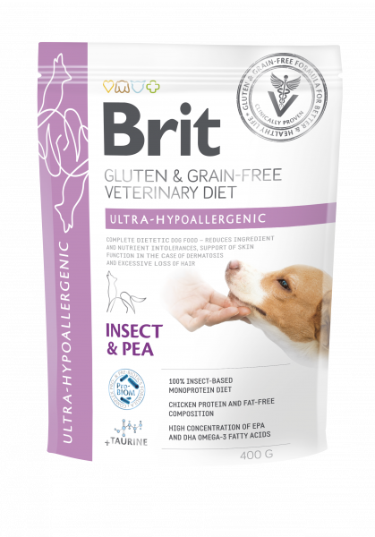
12 kg & 2 kg & 0.4 kg

GASTROINTESTINAL-LOW FAT
COMPLETE DIETETIC FOOD FOR DOGS WITH LIPID ABSORPTION DISORDER, PROTEIN LOSING ENTEROPATHY, AND PANCREATITIS

INDICATIONS
- REDUCES SYMPTOMS OF PROTEINLOSING ENTEROPATHY
- NUTRITIONAL SUPPORT DURING PANCREATITIS
- DIET SUITABLE FOR DOGS SUFFERING WITH TRIADITIS

BENEFITS
- EASILY DIGESTIBLE PROTEINS OF HIGH BIOLOGICAL VALUE AND LOW-FAT CONTENT
- REDUCES SYMPTOMS OF PROTEIN LOSING ENTEROPATHY, PANCREATITIS AND EXOCRINE PANCREATIC INSUFFICIENCY
- NO RISK OF ALLERGY/INTOLERANCE TO GLUTEN OR CHICKEN PROTEIN
- SUPPORTS THE INTESTINAL MICROBIOME AND IMMUNE SYSTEM

COMPOSITION:
yellow peas (35%), dehydrated herring (20%), buckwheat, hydrolysed salmon protein (12%), dried apple pulp, salmon oil (3%), eggs (2%), hydrolysed salmon gravy (2%), egg shells (a source of calcium), psyllium husks and seeds (1%), brewer´s yeast (1%), sodium chloride, pea flour, dried algae (0.5%, Ascophyllum nodosum), potassium chloride, yeast extract (source of mannan-oligosaccharides, 0.025%), β-glucans (0.022%), fructo-oligosaccharides (0.02%), Mojave yucca (0.02%), dried sea buckthorn (0.015%), Lactobacillus helveticus HA – 122 inactivated (15x109 cells/kg).

METABOLISABLE ENERGY:
3,515 kcal/kg.

ANALYTICAL CONSTITUENTS:
crude protein 24.0 %, crude fat 7.0 %, crude fibre 1.5 %, crude ash 5.3 %, moisture 10.0 %, total sugars (as NFE) 52.2 %, omega-3 fatty acids 1.3 %, omega-6 fatty acids 0.6 %, calcium 0.9 %, phosphorus 0.6 %, sodium 0.5 %, magnesium 0.09 %, potassium 0.7 %.

NUTRITIONAL ADDITIVES PER 1 KG:
vitamin A (3a672a) 22,000 IU, vitamin D3 (3a671) 1,000 IU, vitamin E (3a700) 1,000 mg, vitamin C (3a312) 500 mg, choline chloride (3a890) 2,300 mg, biotin (3a880) 2.4 mg, vitamin B1 (3a821) 11 mg, vitamin B2 (3a825i) 14 mg, niacinamide (3a315) 94 mg, calcium-D-pantothenate (3a841) 25 mg, vitamin B6 (3a831) 7 mg, folic acid (3a316) 2.4 mg, vitamin B12 0.16 mg, zinc (3b606) 140 mg, iron (3b106) 65 mg, manganese (3b504) 75 mg, iodine (3b201) 4.2 mg, copper (3b406) 5 mg, selenium (3b810) 0.2 mg, L-carnitine (3a910) 350 mg, taurine (3a370) 2,000 mg.
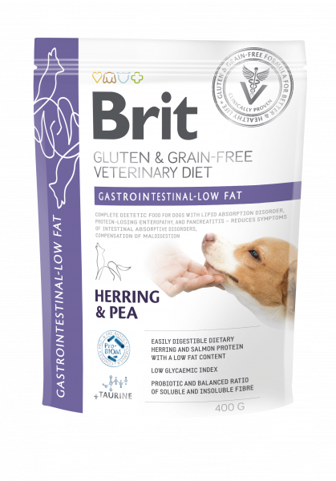
12 kg & 2 kg & 0.4 kg

STERILISED
COMPLETE FOOD FOR STERILISED ADULT DOGS OF ALL BREEDS

INDICATIONS
- WEIGHT CONTROL IN STERILISED DOGS
- BODY CONDITION SUPPORT IN STERILISED DOGS
- SUPPORT OF HEALTHY SKIN AND COAT & URINARY TRACT

BENEFITS
- WEIGHT CONTROL AND CONDITION SUPPORT IN STERILISED DOGS
- NUTRITIONAL SUPPORT OF SKIN AND COAT AND URINARY TRACT HEALTH
- NO RISK OF ALLERGY/INTOLERANCE TO GLUTEN OR CHICKEN PROTEIN
- SUPPORTS THE INTESTINAL MICROBIOME AND IMMUNE SYSTEM

COMPOSITION:
dehydrated salmon (30%), yellow peas, hydrolysed salmon protein (14%), dried apple pulp, coconut oil, lignocellulose (3%), salmon oil (3%), hydrolyzed salmon gravy (2%), sodium chloride, psyllium husk & seeds (1%), potassium chloride, pea flour, glucosamine (0.11%), dried Vaccinium vitis-idaea (0.2%), dried Urtica dioica (0.12%), dried Carlina acaulis (0.08%), chondroitine sulphate (0.079%), β-glucans (0.02%), fructo-oligosaccharides (0.02%), yeast extract (source of mannan-oligosaccharides, 0.014%), methyl sulfonyl methan (0.013%), dried sea buckthorn (0.01%), Boswellia serrata (0.008%), green-lipped mussels (0.007%), Mojave yucca (0.007%), Lactobacillus helveticus HA – 122 inactivated (15x109 cells/kg).

METABOLISABLE ENERGY:
3,460 kcal/kg.

ANALYTICAL CONSTITUENTS:
crude protein 26.0 %, crude fat 12.0 %, crude fibre 5.0 %, crude ash 7.5 %, moisture 10.0 %, omega-3 fatty acids 1.0 %, omega-6 fatty acids 0.9 %, calcium 1.2 %, phosphorus 0.8 %, sodium 1.1 %, potassium 0.5%, magnesium 0.05 %.

NUTRITIONAL ADDITIVES PER 1 KG:
vitamin A (3a672a) 22,000 IU, vitamin D₃ (3a671) 1,500 IU, vitamin E (3a700) 400 mg, vitamin C (3a312) 400 mg, choline chloride (3a890) 450 mg, biotin (3a880) 0.6 mg, vitamin B1 (3a821) 4.5 mg, vitamin B2 (3a825i) 5.8 mg, niacinamide (3a315) 27 mg, calcium-D-pantothenate (3a841) 13.5 mg, vitamin B6 (3a831) 4.8 mg, folic acid (3a316) 0.7 mg, vitamin B12 0.04 mg, zinc (3b606) 85 mg, iron (3b106) 65 mg, manganese (3b504) 32 mg, iodine (3b201) 0.6 mg, copper (3b406) 12.5 mg, selenium (3b810) 0.18 mg, L-carnitine (3a910) 350 mg, taurine (3a370) 2,000 mg.
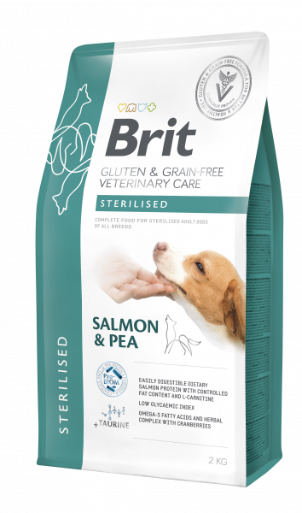
12 kg & 2 kg & 0.4 kg

VEG HIGH FIBRE
HIGH FIBRE COMPLEMENTARY DOG FOOD FOR FIBRE RESPONSIVE DISORDERS AND WEIGHT MANAGEMENT

INDICATIONS
- WEIGHT MANAGEMENT OF DOGS PRONE TO OBESITY
- FIBRE RESPONSIVE INTESTINAL DISORDERS
- SUPPORT OF GASTROINTESTINAL MICROBIOM

BENEFITS
- NUTRITIONAL SUPPORT FOR DOGS SUFFERING FROM COLITIS AND FIBRE-RESPONSIVE DIARRHOEA
- NO RISK OF ALLERGY/INTOLERANCE TO ANIMAL PROTEIN AND GLUTEN
- SUPPORTS THE INTESTINAL MICROBIOME AND IMMUNE SYSTEM

COMPOSITION:
yellow peas, pea protein, dried apple pulp, coconut oil, lignocellulose, linseed (5%), red lentils, hydrolysed yeast, psyllium husk & seeds (2%), milkt thistle seed (1%), Mojave yucca (1%), dried olive pulp (1%), dried kelp (Ascophyllum nodosum), mannan-oligosaccharides (0.5%), dried algae (0.5%, Schizochytrium limacinum).

METABOLISABLE ENERGY:
3,200 kcal/kg.

ANALYTICAL CONSTITUENTS:
crude protein 15.0 %, crude fat 10.0 %, crude fibre 10.0 %, crude ash 2.4 %, moisture 10.0 %, omega-3 fatty acids 1.0 %, omega-6 fatty acids 0.3 %, EPA (20:5 n-3) 0.1 %, DHA (22:6 n-3) 0.15 %, calcium 0.1 %, phosphorus 0.2%.
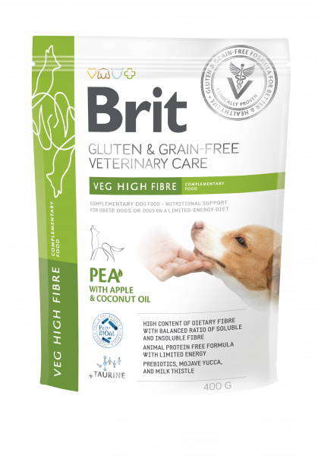
2 kg & 0.4 kg

HEPATIC
Dietetic Complete Feed for dogs - support of liver function in the case of chronic liver insufficiency

INDICATIONS
- Hepatic insufficiency and hepatic failure
- Portosystemic shunt (PSS)
- Hepatic encephalopathy
- Convalescence following intoxication

BENEFITS

GRAIN-FREE
low glycemic index

LOW ANIMAL PROTEIN CONTENT
Low animal protein content 16%

MILK THISTLE SEEDS
Antisource of silymarin, support of recover liver cells

TASTY EGGS / HYDROLYSED TURKEY PROTEIN
highly digestible sources of proteins

LOW COPPER CONTENT / HIGH ZINC CONTENT
limits accumulation of copper in liver tissue

FAT CONTENT 16%
more energy (3,850 kcal/kg) in smaller quantity of food

ANTIOXIDANTS
Antioxidants A, C, E

YELLOW PEAS / CASSAVA ROOT STARCH / SWEET POTATOES
gluten-free, high digestibility

KELP (ASCOPHYLLUM NODOSUM)
tural source of I2 / K + aminoacids, source of prebiotic fibre for balanced intestinal microflora

SEA BUCKTHORN
antioxidant properties, immune stimulation, anti-inflammatory action, wound healing properties
- TURKEY WITH PEA
- EGGS, PEA, SWEET POTATOES & BUCKWHEAT

FEEDING TABLE:
WEIGHT OF THE DOG (KG) | 5-10 | 10-30 | 30-60
DAILY DOSE (G) | 200 - 400 | 400 – 800 | 800 – 1 400

COMPOSITION:
turkey (55%), green peas (4%), salmon oil (2%), pea flour, lignocellulose, calcium carbonate, dried algae (0.5%, Ascophyllum nodosum), milk thistle seeds (0.2%), mannan-oligosaccharides (0.005%), fructo-oligosaccharides (0.005%), Mojave yucca (0.0034%), β-glucans (0.004%), dried sea buckthorn (0.003%).

METABOLISABLE ENERGY:
1,330 kcal/kg.

ANALYTICAL CONSTITUENTS:
crude protein 9.0 %, fat content 9.0 %, crude ash 2.0 %, moisture 78.0 %, crude fibre 1.0 %, total sugars (as NFE) 4.0 %, calcium 0.1 %, phosphorus 0.3 %, sodium 0.2 %, magnesium 0.08 %, copper 0.1 %, omega 3 0.1 %, omega 6 0.2 %

NUTRITIONAL ADDITIVES PER 1 KG:
vitamin A (3a672a) 5,000 I.U., vitamin D3 (3a671) 200 I.U., vitamin E (3a700) 200 mg, vitamin C (3a312) 100 mg, biotin (3a880) 0.6 mg, zinc (3b606) 40 mg, iron (3b106) 15 mg, manganese (3b504) 15 mg, potassium iodide (3b201) 1.0 mg, selenium (3b8.10) 0.05 mg, taurine (3a370) 600 mg, L-cartinine (3a910) 80 mg. Technological additives per 1 kg: carob gum (E 410) 5,000 mg.
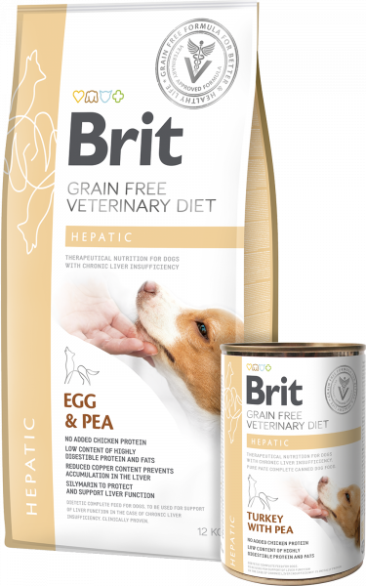
0.4 kg
12 kg & 2 kg

JOINT & MOBILITY
Dietetic Complete Feed for dogs – support of the metabolism of joints in the case of osteoarthritis

INDICATIONS
- Joint and cartilage diseases
- Genetic predisposition to joint diseases

BENEFITS

GRAIN-FREE
low glycemic index, prevents weight gain

TASTY HERRING, DEHYDRATED / HYDROLYSED SALMON PROTEIN
highly digestible sources of protein

CHONDROITIN 1,200 MG, BOSWELLIA SERRATA 130 MG / VITAMIN C 500 MG
joint and cartilage support

GLUCOSAMINE 1,500 MG, MSM 200 MG, GREEN-LIPPED MUSSEL EXTRACT 100 MG
support of joints and cartilage condition

HIGH OMEGA-3 CONTENT
High omega-3 content 3.3%

HYDROLYZED COLLAGEN OF TYPE I.
reduction of stiffness, limping and pain reduction

YELLOW PEAS / BUCKWHEAT
gluten-free, high digestibility

KELP (ASCOPHYLLUM NODOSUM)
natural source of I2 / K + aminoacids, source of prebiotic fibre for balanced intestinal microflora

SEA BUCKTHORN
antioxidant properties, immune stimulation, anti-inflammatory action, wound healing properties
- HERRING, SALMON, PEA & BUCKWHEAT
- HERRING WITH PEA

METHOD OF USE:
INITIAL FEEDING PERIOD:
Use Brit VD Joint & Mobility Dog initially for a period of up to 6 months. Maximum effect of Brit VD Joint & Mobility Dog can be expected during the first 2 months. In case of acute osteoarthritis or mobility problem consult with your veterinarian use of additional medication for pain and inflammation management during initial feeding period. Consult anytime any additional treatment and follow-up examination with your veterinarian.
LONG-TERM FEEDING:
Maintaining optimal weight and activity in dogs with degenerative joints disease (DJD) is essential for long-term activity. Regular checks of body weight are essential for effective management of DJD.

FEEDING TABLE:
DOG WEIGHT (KG) | 2 | 5 | 10 | 15 | 20 | 25 | 30 | 40 | 50 | 60 | 70 | 80
DAILY AMOUNT (G) | 30 | 75 | 130 | 170 | 210 | 250 | 290 | 360 | 420 | 480 | 540 | 600

COMPOSITION:
dehydrated herring (28%), yellow peas (24%), hydrolysed salmon protein (10%), buckwheat, apple pulp, flaxseed (6%), chicken fat (5%), collagen (3%, type I. hydrolyzed), salmon oil (3%), hydrolysed chicken liver (2%), minerals, dried algae (0.5%, Ascophyllum nodosum), dried algae (0.4%, Schizochytrium limacinum), hydrolysed crustacean shells (a source of glucosamine sulphate 0.15%), hydrolysed cartilage (a source of chondroitin sulphate, 0.12%), methyl sulphonyl methane (0.02%), yeast extract (source of mannan-oligosaccharides, 0.02%), β-glucans (0.02%), egg shell membrane (0,015%), sea buckthorn (0.015%), fructo-oligosaccharides (0.013%), Boswellia serrata (0.013 mg/kg), Mojave yucca (0.012%), green-lipped mussel extract (Perna canaliculus, 0.01%).

METABOLISABLE ENERGY:
3,720 kcal/kg

ANALYTICAL CONSTITUENTS:
crude protein 29.0 %, fat content 13.0 %, crude fibre 2.5 %, crude ash 6.0 %, moisture 10 %, omega-3 3.3 %, omega-6 1.9 %, EPA (20:5 n-3) 0.40 %, DHA (22:6 n-3) 0.55 %, calcium 0.8 %, phosphorus 0.6 %, sodium 0.6 %, magnesium 0.08 %, vitamin E 500 mg/kg

NUTRITIONAL ADDITIVES PER 1 KG:
vitamin A (3a672a) 22,000 I.U., vitamin D3 (E671) 1,800 I.U., vitamin E (3a700) 500 mg, vitamin C (3a312) 500 mg, choline chloride (3a890) 650 mg, biotin (3a880) 0.8 mg, vitamin B1 (3a821) 6.5 mg, vitamin B2 8.4 mg, niacinamide (3a315) 38 mg, calcium-D-panthothenate (3a841) 19 mg, vitamin B6 (3a831) 6.5 mg, folic acid 3a316) 0.9 mg, vitamin B12 0.05 mg, zinc chelate of amino acids hydrate (3b606) 120 mg, ferrous chelate of amino acids hydrate (E1) 90 mg, manganese chelate if amino acids hydrate (E5) 45 mg, potassium iodide (3b201) 0.8 mg, cupric chelate of amino acids hydrate (E4) 20 mg, organic form of Selenium produced by Saccaromyces cerevisiae CNCM I-3060 (selenised yeast inactivated) (3b8.10) 0.2 mg, L-carnitine (3a910) 500 mg. Gut flora stabilisers per 1 kg: Enterococcus faecium DSM 10663/NCIMB 10415 (4b1707) 1x109 CFU

Contains EU approved antioxidants: tocopherol extracts from vegetable oil (1b306), ascorbyl palmitate (1b304) & rosemary extract.
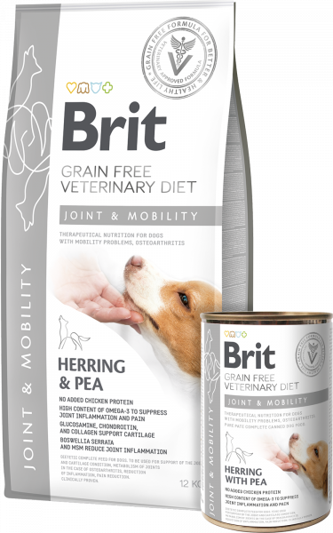
2 kg & 12 kg
0.4 kg

RECOVERY
Complete dietary pet food for dogs and cats, essential for their nutritional rejuvenation and regeneration.

INDICATIONS
- During recovery
- Recuperation after an operation or severe illness
- Reduced appetite

BENEFITS

HIGH CONCENTRATION OF ENERGY
for quick renewal of strength and regeneration

EASILY DIGESTIBLE ANIMAL PROTEINS
of high biological value

GRAINLESS INGREDIENTS
limit the negative impact of gluten to an organism

TAURINE, GLUTAMATE, L-ARGININE, AND L-METHIONINE
accelerate healing and regeneration

HIGH CONTENT VALUE OF EPA AND DHA, Β-GLUCANS, MOS AND FOS
for immunity support

SOFT TEXTURE
for easy feeding by hand, syringe or feeding tube

DELICIOUS TASTE
helps dogs and cats with inappetence issues to better ingest their food

FEEDING TABLE:
WEIGHT OF THE DOG (KG) | 5-10 | 10-30 | 30-60
DAILY DOSE (G) | 200 - 400 | 400 - 800 | 800 - 1300

COMPOSITION:
salmon (30%), chicken liver (25%), salmon oil (2%), pea flour, brewer´s yeast (1.5%), lignocellulose, calcium carbonate, dried algae (0.5%, Schizochytrium limacinum), psyllium husks and seeds (0.5%), dried algae (0.5%, Ascophyllum nodosum), mannan-oligosaccharides (0.006%), β-glucans (0.005%), fructo-oligosaccharides (0.005%), Mojave yucca (0.005%), dried sea buckthorn (0.004%).

METABOLISABLE ENERGY:
1 090 kcal/kg

ANALYTICAL CONSTITUENTS:
crude protein 9.0 %, crude fat 8.0 %, crude ash 1.5 %, moisture 80.0 %, crude fiber 1.5 %, calcium 0.1 %, phosphorus 0.25 %, sodium 0.2 %, magnesium 0.1 %, EPA (20:5 n-3) 0.01 %, DHA (22:6 n-3) 0.15 %, omega 3 0.3 % omega 6 0.2 %

NUTRITIONAL ADDITIVES PER 1 KG:
vitamin A (3a672a) 5,000 I.U., vitamin D3 (3a671) 350 I.U., vitamin E (3a700) 200 mg, vitamin C (3a312) 150 mg, biotin (3a880) 0.7 mg, zinc (3b606) 55 mg, iron (3b106) 20 mg, manganese (3b504) 20 mg, potassium iodide (3b201) 1.3 mg, copper (3b406) 4 mg, selenium (3b8.10) 0.05 mg, taurine (3a370) 1,500 mg, monosodium glutamate (2b621) 3,000 mg, L-arginine (3c3.6.1) 1,000 mg, L-methionine (3c305) 2,000 mg. Technological additives per 1 kg: carob gum (E 410) 5,000 mg.
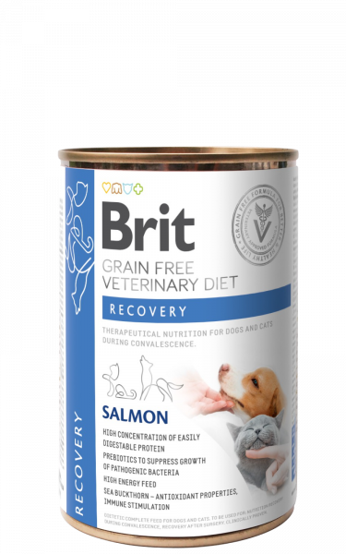
0.4 kg

ARE YOU INTERESTED IN THIS PRODUCT?

HYPOALLERGENIC
Dietetic Complete Feed for cats - reduction of ingredient and nutrient intolerances.

INDICATIONS
- Food allergies with dermatological or gastrointestinal symptoms
- Food intolerance
- Otitis externa, atopic dermatitis
- Support of health and quality of hair and skin
- Frequent diarrhoea and bowel infections
- Soothing of digestive tract
- Long-term nutrition following elimination diet

BENEFITS

GRAIN-FREE
low glycemic index, optimal digestion, lowers risk of allergic reaction

SINGLE PROTEIN SOURCE - TASTY SALMON, DEHYDRATED
highly digestible source of protein

HYDROLYSED SALMON PROTEIN
highly digestible and unlikely to cause allergies, under 5 000 Da

HIGH CONTENT OF OMEGA-3 (1%)
support of healthy skin and coat

BIOTIN 4 MG / ZINC 150 MG / VITAMIN C 500 MG
skin barrier support, healing effect

YELLOW PEAS / BUCKWHEAT
gluten-free, hypoallergenic properties, high digestibility

KELP (ASCOPHYLLUM NODOSUM)
natural source of I2 / K + aminoacids, source of prebiotic fibre for balanced intestinal microflora

SOY FREE
limitation of anti-nutritional compounds, such as phytates and phytoestrogens, which disrupt hormone levels, elimination of allergies

SEA BUCKTHORN
antioxidant properties, immune stimulation, anti-inflammatory action, wound healing properties

SCHIZOCHYTRIUM LIMACINUM
concentrated source of DHA
- SALMON & PEA
- SALMON WITH PEAS

METHOD OF USE:
ELIMINATION OF FOOD ALLERGY REACTIONS AND FOOD INTOLERANCE:
Feed only Brit VD Hypoallergenic Cat and water for 6–8 weeks. Do not feed any other pet food or human food, snacks, or supplements.
MAINTAINING DIET:
If intolerance and/or allergies desist, Brit VD Hypoallergenic Cat may be used indefinitely or to start a dietary provocation test for a mono-protein diet.

FEEDING TABLE:
CAT WEIGHT (KG) | 2 | 3 | 4 | 5 | 6 | 8 | 10 | 12
DAILY AMOUNT (G/DAY) | 55 | 65 | 70 | 80 | 85 | 95 | 100 | 120

COMPOSITION:
dehydrated salmon (30%), yellow peas (20%), hydrolysed salmon protein (20%), coconut oil, buckwheat, yellow pea protein, apple pulp, hydrolysed salmon gravy (2%), salmon oil (2%), minerals, dried algae (0.5%, Ascophyllum nodosum), dried algae (0.4%, Schizochytrium limacinum), yeast extract (source of mannan-oligosaccharides, 0.02%), β-glucans (0.02%), sea buckthorn (0.015%), fructo-oligosaccharides (0.013%), Mojave yucca (0.013%)

METABOLISABLE ENERGY:
3,900 kcal/kg

ANALYTICAL CONSTITUENTS:
crude protein 29.0 %, fat content 17.0 %, crude fibre 1.5 %, crude ash 7.2 %, moisture 10 %, omega-3 1.0 %, omega-6 0.85 %, calcium 1.3 %, phosphorus 0.9 %, EPA (20:5 n-3) 0.3 %, DHA (22:6 n-3) 0.55 %, sodium 0.3 %, magnesium 0.09 %

NUTRITIONAL ADDITIVES PER 1 KG:
vitamin A (3a672a) 25,000 I.U., vitamin D3 (E671) 850 I.U., vitamin E (3a700) 700 mg, vitamin C (3a312) 500 mg, choline chloride (3a890) 2,300 mg, biotin (3a880) 4 mg, vitamin B1 (3a821) 10 mg, vitamin B2 30 mg, niacinamide (3a315) 50 mg, calcium-D-panthothenate (3a841) 50 mg, vitamin B6 (3a831) 35 mg, folic acid (3a316) 15 mg, vitamin B12 0.03 mg, zinc chelate of amino acids hydrate (3b606) 150 mg, ferrous chelate of amino acids hydrate (E1) 110 mg, manganese chelate if amino acids hydrate (E5) 65 mg, potassium iodide (3b201) 4.2 mg, cupric chelate of amino acids hydrate (E4) 12 mg, organic form of Selenium produced by Saccaromyces cerevisiae CNCM I-3060 (selenised yeast inactivated) (3b8.10) 0.2 mg, taurine (3a370) 2,600 mg, L-carnitine (3a910) 75 mg, L-methionine (3c305) 4 000 mg. Gut flora stabilisers per 1 kg: Enterococcus faecium DSM 10663/NCIMB 10415 (4b1707) 1x109 CFU
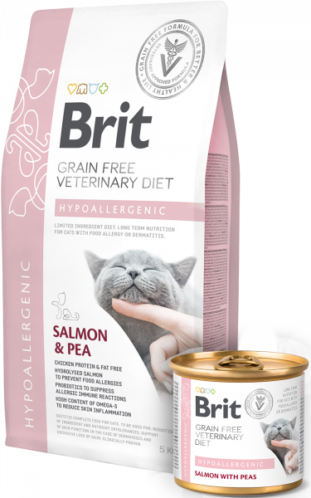
2 kg & 0.4 kg & 0.4 kg & 0.4 kg & 0.4 kg
0.2 kg

GASTROINTESTINAL
Dietetic Complete Feed for cats - reduction of acute intestinal absorptive disorders, compensation of maldigestion grain-free food for cats with gastrointestinal problems

INDICATIONS
- Gastrointestinal disorders (diarrhoea, vomiting)
- Soothing of the digestive tract after diarrhoea or vomiting
- Pancreatitis
- Inflammatory bowel disease (IBD)
- Digestive disorders, malabsorption

BENEFITS

GRAIN-FREE
low glycemic index, soothes the digestive

TASTY HERRING, DEHYDRATED / HYDROLYSED SALMON PROTEIN / EGGS
Antihighly digestible sources of protein

PROTEIN AND FAT
more energy in smaller quantity of food

YELLOW PEAS / BUCKWHEAT
gluten-free, high digestibility

HIGH OMEGA-3 CONTENT (1.1%)
support the optimal condition of intestine

KELP (ASCOPHYLLUM NODOSUM)
natural source of I2 / K + aminoacids, source of prebiotic fibre for balanced intestinal microflora

BREWER’S YEAST
prebiotic properties – prevention of digestive problems, diarrhoea

MOS / FOS / Β-GLUCANS
prebiotics for optimal intestinal microflora

SEA BUCKTHORN
antioxidant properties, immune stimulation
- SALMON WITH PEAS
- HERRING, SALMON, EGGS, AND PEA

FEEDING TABLE:
WEIGHT OF THE CAT (KG) | 2 | 4 | 6 | 10
DAILY DOSE (G) | 200 | 350 | 450 | 600

COMPOSITION:
salmon (55%), green peas (3%), brewer´s yeast (2%), pea flour, salmon oil (2%), lignocellulose, montmorillonite (0.5%), dried algae (0.5%, Ascophyllum nodosum), mannan-oligosaccharides (0.012%), β-glucans (0.01%), fructo-oligosaccharides (0.008%), Mojave yucca (0.008%), dried sea buckthorn (0.006%)

METABOLISABLE ENERGY:
1,075 kcal/kg

ANALYTICAL CONSTITUENTS:
crude protein 9.0 %, crude fat 7.0 %, crude ash 2.5 %, moisture 78.0 %, crude fiber 1.0 %, calcium 0.2 %, phosphorus 0.25 %, sodium 0.6 %, magnesium 0.03 %, potassium 0.3 %, omega 3 fatty acids 0.2 %, omega 6 fatty acids 0.2 %

NUTRITIONAL ADDITIVES PER 1 KG:
vitamin A (3a672a) 6,000 IU, vitamin D3 (3a671) 200 mg, vitamin E (3a700) 300 mg, vitamin C (3a312) 100 mg, biotin (3a880) 1.2 mg, zinc (3b606) 50 mg, iron (3b106) 25 mg, manganese (3b504) 25 mg, potassium iodide (3b201) 1.8 mg, copper (3b406) 1.5 mg, selenium (3b810) 0.1 mg, L-methionine (3c305) 2,000 mg, L-arginine (3c3.6.1) 1,000 mg, taurine (3a370) 1,500 mg, monosodium glutamate (2b621) 3,000 mg. Technological additives per 1 kg: carob gum (E 410) 5,000 mg.
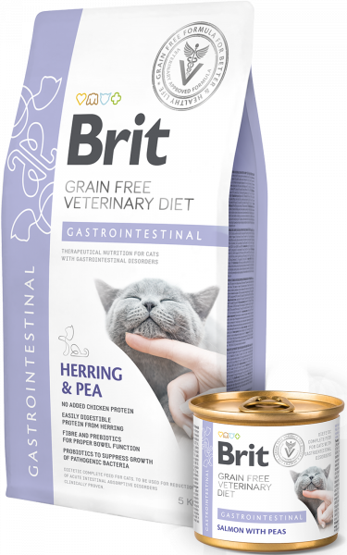
0.2 kg
0.4 kg & 2 kg & 5 kg

OBESITY
Dietetic Complete Feed for cats - reduction of excessive body weight

INDICATIONS
- Obesity and excess weight
- Tendency to gain weight following castration

CONTRAINDICATIONS
- Kittens
- Pregnant and nursing cats

BENEFITS

GRAIN-FREE
low glycemic index, reduces risk of obesity

TASTY CHICKEN, DEHYDRATED
highly digestible source of protein

HIGH PROTEIN CONTENT 43%
muscle mass maintenance

HIGH FIBRE CONTENT WITH L-CARNITINE 600 MG
facilitates weight loss

PSYLLIUM SEEDS
water-soluble source of fibre, intestinal scrubbing, improved weight loss

YELLOW PEAS
gluten-free, high digestibility

KELP (ASCOPHYLLUM NODOSUM)
natural source of I2 / K + aminoacids, source of prebiotic fibre for balanced intestinal microflora

CHONDROPROTECTIVES
promote joint cartilage health

SEA BUCKTHORN
antioxidant properties, immune stimulation
- LAMB WITH PEAS
- CHICKEN & PEA

FEEDING TABLE:
WEIGHT OF THE CAT (KG) | 2 | 4 | 6 | 10
DAILY DOSE (G) | 200 | 350 | 450 | 600

COMPOSITION:
lamb (55%), green peas (3%), salmon oil (2%), pea flour, lignocellulose (2%), psyllium husks and seeds (0.5%), dried algae (0.5%, Ascophyllum nodosum), glucosamine (0.015%), chondroitin sulphate (0.01%), mannan-oligosaccharides (0.01%), β-glucans (0.008%), dried sea buckthorn (0.006%), fructo-oligosaccharides (0.005%), Mojave yucca (0.005%)

METABOLISABLE ENERGY:
1,070 kcal/kg

ANALYTICAL CONSTITUENTS:
crude protein 9.0 %, crude fat 7.0 %, crude ash 2.0 %, moisture 78.0 %, crude fiber 3.0 %, calcium 0.2 %, phosphorus 0.25 %, sodium 0.5 %, magnesium 0.02 %, omega 3 fatty acids 0.1 %, omega 6 fatty acids 0.2 %

NUTRITIONAL ADDITIVES PER 1 KG:
vitamin A (3a672a) 6,000 IU, vitamin D3 (3a671) 200 mg, vitamin E (3a700) 300 mg, vitamin C (3a312) 100 mg, biotin (3a880) 1.2 mg, zinc (3b606) 45 mg, iron (3b106) 20 mg, manganese (3b504) 15 mg, potassium iodide (3b201) 1.5 mg, copper (3b406) 1.5 mg, selenium (3b810) 0.1 mg, taurine (3a370) 1,100 mg, L-carnitine (3a910) 250 mg, L-methionine (3c305) 2,000 mg, L-arginine (3c3.6.1) 10 mg. Technological additives per 1 kg: carob gum (E 410) 5,000 mg.
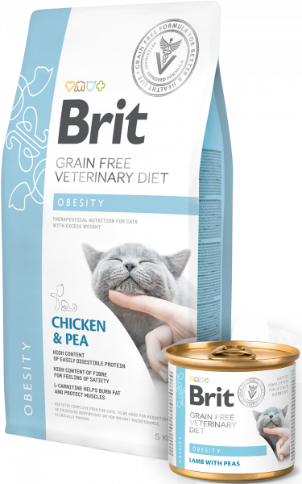
0.2 kg
5 kg & 2 kg & 0.4 kg

DIABETES
Dietetic Complete Feed for cats - regulation of glucose supply (Diabetes mellitus)

INDICATIONS
- Diabetes mellitus
- Maintenance of optimal weight
- Added fibre for satiety

CONTRAINDICATIONS
- Kittens
- Pregnant and nursing cats

BENEFITS

GRAIN FREE
low glycemic index, lowers the risk of postprandial hyperglycemia

TASTY CHICKEN, DEHYDRATED
high-quality, and digestible source of protein

HIGH PROTEIN CONTENT 46%
muscle mass & weight maintenance

LOW SIMPLE SUGARS CONTENT 0.8% / STARCH 15%
positive impact on blood glucose levels

ANTIOXIDANTS A, C, E
lessen the effects of oxidative stress

PSYLLIUM SEEDS
water-soluble source of fibre, intestinal scrubbing, improved weight loss

YELLOW PEAS
gluten free, hypoallergenic properties, high digestibility

KELP (ASCOPHYLLUM NODOSUM)
natural source of I2 / K + aminoacids, source of prebiotic fibre for balanced intestinal microflora

CHONDROPROTECTIVES
promote joint cartilage health

SEA BUCKTHORN
antioxidant properties, immune stimulation
- LAMB WITH PEAS
- CHICKEN & PEA

FEEDING TABLE:
WEIGHT OF THE CAT (KG) | 2 | 4 | 6 | 10
DAILY DOSE (G) | 200 | 350 | 450 | 600

COMPOSITION:
lamb (55%), green peas (3.5%), salmon oil (2%), pea flour, lignocellulose (1%), psyllium husks and seeds (0.5%), dried algae (0.5%, Ascophyllum nodosum), glucosamine (0.015%), chondroitin sulphate (0.01%), mannan-oligosaccharides (0.01%), β-glucans (0.008%), dried sea buckthorn (0.006%), fructo-oligosaccharides (0.005%), Mojave yucca (0.005%).

METABOLISABLE ENERGY:
1,130 kcal/kg

ANALYTICAL CONSTITUENTS:
crude protein 9.0 %, crude fat 8.0 %, crude ash 2.0 %, moisture 78.0 %, total sugars (as NFE) 1.5 %, crude fiber 2.0 %, calcium 0.2 %, phosphorus 0.25 %, sodium 0.5 %, starch 2 %, total sugars 0.5 %, magnesium 0.02 %, omega 3 fatty acids 0.1 %, omega 6 fatty acids 0.2 %

NUTRITIONAL ADDITIVES PER 1 KG:
vitamin A (3a672a) 6,000 IU, vitamin D3 (3a671) 200 mg, vitamin E (3a700) 300 mg, vitamin C (3a312) 100 mg, biotin (3a880) 1.2 mg, zinc (3b606) 45 mg, iron (3b106) 20 mg, manganese (3b504) 15 mg, potassium iodide (3b201) 1.5 mg, copper (3b406) 1.5 mg, selenium (3b810) 0.1 mg, taurine (3a370) 1,100 mg, L-cartinine (3a910) 250 mg, L-methionine (3c305) 2,000 mg, L-arginine (3c3.6.1) 10 mg. Technological additives per 1 kg: carob gum (E 410) 5,000 mg.
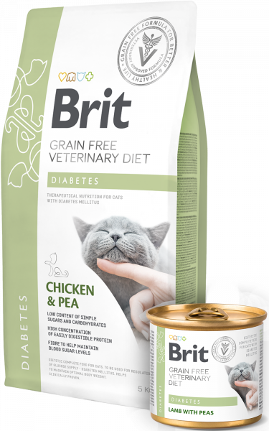
0.2 kg
0.4 kg & 2 kg & 5 kg

STRUVITE
Dietetic Complete Feed for cats - dissolution of struvite stones, reduction of struvite stone recurrence

INDICATIONS
- Dissolution of struvite stones
- Prevention of struvite recurrence
- Urinary tract diseases
- Urinary tract bacterial infections

BENEFITS

GRAIN-FREE
low glycemic index

CALCIUM SULPHATE / L-METHIONINE / SODIUM CHLORIDE
accelerates dissolution of struvite stones

L-TRYPTOPHAN
calming effect

SODIUM CHLORIDE
dilutes dilution, limits formation of struvite / oxalate stones

LOW MAGNESIUM 0.06%
eliminates the reformation of struvite stones

OMEGA-3
High omega-3 content 0.6%

ANTIOXIDANTS
Antioxidants A, C, E

YELLOW PEAS / BUCKWHEAT
gluten-free, high digestibility

KELP (ASCOPHYLLUM NODOSUM)
natural source of I2 / K + aminoacids, source of prebiotic fibre for balanced intestinal microflora

SEA BUCKTHORN
antioxidant properties, immune stimulation

VACCINIUM VITIS-IDAEA
cranberries, urinary tract support
- CHICKEN & PEA
- TURKEY WITH PEAS

METHOD OF USE:
STRUVITE DISSOLUTION:
Use Brit VD Struvite Cat for a period of 5–12 weeks for struvite dissolution. Regularly check urine target pH (6.2–6.4) and kidney function in ageing cats.
PREVENTION OF STRUVITE RECURRENCE:
Use Brit VD Struvite Cat based on urine analysis for a period of up to 6 months to prevent the recurrence of struvite stones. Regularly check urine target pH (6.2–6.4).

FEEDING TABLE:
CAT WEIGHT (KG) | 2 | 3 | 4 | 5 | 6 | 8 | 10 | 12
DAILY AMOUNT (G/DAY) | 55 | 65 | 75 | 80 | 90 | 100 | 110 | 130

COMPOSITION:
dehydrated chicken (20%), yellow peas (16%), yellow pea protein, chicken fat (10%), hydrolysed chicken protein (10%), buckwheat, green peas (6%), sodium chloride (3%), apple pulp, potato protein, salmon oil (2%), hydrolysed chicken liver (2%), minerals, brewer’s yeast, calcium sulphate (0.7%, urine acidifying substance), dried algae (0.5%, Ascophyllum nodosum), cranberries (0.3%, Vaccinium vitis-idaea), yeast extract (source of mannan-oligosaccharides, 0.022%), β-glucans (0.02%), fructo-oligosaccharides (0.02%), Mojave yucca (0.02%), sea buckthorn (0.015%).

METABOLISABLE ENERGY:
3,800 kcal/kg

ANALYTICAL CONSTITUENTS:
crude protein 34.0 %, fat content 16.0 %, crude fibre 2.2 %, crude ash 8.7 %, moisture 10 %, omega 3 0.6 %, omega 6 2.1 %, calcium 0.8 %, phosphorus 0.7 %, sodium 1.3 %, magnesium 0.06 %, potassium 0.45 %, chlorides 1.8 %, sulphur 0.6 %, taurine 0.23 %, hydroxyproline 0.4 %, vitamin D 500 I.U./kg, methionine 1.0 %

NUTRITIONAL ADDITIVES PER 1 KG:
vitamin A (3a672a) 25,000 I.U., vitamin D3 (E671) 500 I.U., vitamin E (3a700) 1,000 mg, choline chloride (3a890) 2,300 mg, biotin (3a880) 3 mg, vitamin B1 (3a821) 10 mg, vitamin B2 30 mg, niacinamide (3a315) 100 mg, calcium-D-panthothenate (3a841) 60 mg, vitamin B6 (3a831) 35 mg, folic acid (3a316) 15 mg, vitamin B12 0.18 mg, zinc chelate of amino acids hydrate (3b606) 120 mg, ferrous chelate of amino acids hydrate (E1) 60 mg, manganese chelate if amino acids hydrate (E5) 60 mg, potassium iodide (3b201) 4 mg, cupric chelate of amino acids hydrate (E4) 3.5 mg, organic form of Selenium produced by Saccaromyces cerevisiae CNCM I-3060 (selenised yeast inactivated) (3b8.10) 0.2 mg, taurine (3a370) 2,300 mg, L-carnitine (3a910) 230 mg, L-methionine (3c305) 7 000 mg, L-tryptophan (3.4.1.) 1 400 mg. Gut flora stabilisers per 1 kg: Enterococcus faecium DSM 10663/NCIMB 10415 (4b1707) 1x109 CFU
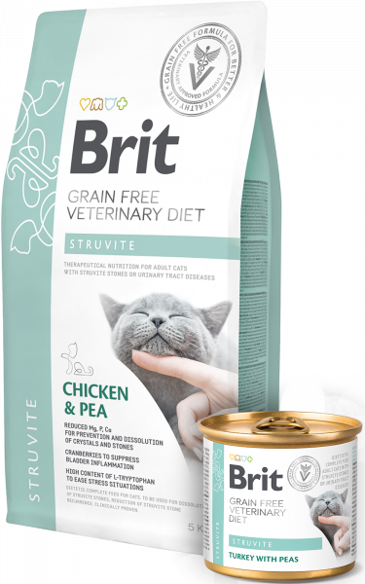
2 kg & 0.4 kg & 5 kg
0.2 kg

RENAL
Dietetic Complete Feed for cats - support of renal function in case of chronic renal insufficiency.

INDICATIONS
- Chronic renal insufficiency

CONTRAINDICATIONS
- Kittens
- Pregnant and nursing cats

BENEFITS

TASTY EGGS / HYDROLYSED CHICKEN PROTEIN
highly digestible source of protein

HIGHER FAT CONTENT 19%
higher energy content 4,000 kcal/kg

POTASSIUM CITRATE / ARGININE
Potassium citrate 8,000 mg / arginine 6,500 mg

LOW PROTEIN / PHOSPHORUS CONTENT
Low protein content 23% / low phosphorus

YELLOW PEAS / BUCKWHEAT
gluten-free, high digestibility

KELP (ASCOPHYLLUM NODOSUM)
natural source of I2 / K + aminoacids, source of prebiotic fibre for balanced intestinal microflora

CHITOSAN
phosphorus binding, renal function support

MOS / FOS / Β-GLUCANS
prebiotics for optimal intestinal microflora

SEA BUCKTHORN
antioxidant properties, immune stimulation
- TUNA & SALMON WITH PEAS
- EGG & PEA

FEEDING TABLE:
WEIGHT OF THE CAT (KG) | 2 | 4 | 6 | 10
DAILY DOSE (G) | 150 | 250 | 300 | 450

COMPOSITION:
tuna (30%), salmon (26%), green peas (3%), pea flour, salmon oil (2%), lignocellulose, potassium citrate (0.6%), dried algae (0.5%, Ascophyllum nodosum), dried algae (0.4%, Schizochytrium limacinum), chitosan (0.05%), mannan-oligosaccharides (0.013%), fructo-oligosaccharides (0.01%), Mojave yucca (0.01%), β-glucans (0.01%), dried sea buckthorn (0.008%)

METABOLISABLE ENERGY:
1,170 kcal/kg

ANALYTICAL CONSTITUENTS:
crude protein 7.0 %, crude fat 9.0 %, crude ash 2.0 %, moisture 78.0 %, crude fiber 1.0 %, calcium 0.2 %, phosphorus 0.25 %, sodium 0.6 %, magnesium 0.02 %, potassium 0.3 %, arginine 0.15 %, taurine 0.11 %, omega 3 fatty acids 0.3 %, omega 6 fatty acids 0.2 %

NUTRITIONAL ADDITIVES PER 1 KG:
vitamin A (3a672a) 6,000 IU, vitamin D3 (3a671) 200 mg, vitamin E (3a700) 300 mg, vitamin C (3a312) 100 mg, biotin (3a880) 1.2 mg, zinc (3b606) 60 mg, iron (3b106) 30 mg, manganese (3b504) 30 mg, potassium iodide (3b201) 2 mg, copper (3b406) 1.8 mg, selenium (3b810) 0.1 mg, taurine (3a370) 1,100 mg, L-carnitine (3a910) 120 mg, L-methionine (3c305) 2,000 mg. Technological additives per 1 kg: carob gum (E 410) 5,000 mg.
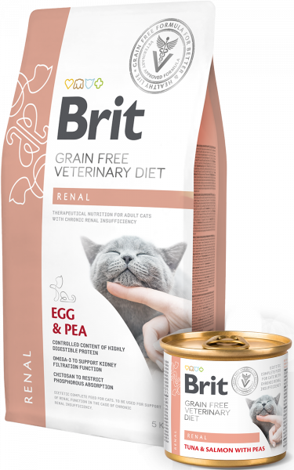
0.2 kg
0.4 kg & 2 kg & 5 kg

ULTRA-HYPOALLERGENIC
COMPLETE AND BALANCED HYPOALLERGENIC DIETETIC CAT FOODWITH INSECT PROTEIN FOR REDUCTION OF FOOD INTOLERANCES

INDICATIONS
- MITIGATION OF SKIN AND DIGESTIVE SYMPTOMS CAUSED BY FOOD ALLERGIES
- REDUCTION OF ATOPIC AND PRURITIC DERMATOLOGICAL SYMPTOMS
- STRENGTHENS THE FORMATION OF THE NATURAL SKIN BARRIER AND IMMUNITY
- SUPPORTS THE HEALINGOF INFLAMMATORY SKIN DISEASES

BENEFITS
- LOW RISK OF FOOD ALLERGIES AND INTOLERANCE TO COMMON PROTEINS
- NO RISK OF ALLERGY/INTOLERANCE TO GLUTEN OR CHICKEN PROTEIN
- STRENGTHENING OF THE NATURAL SKIN BARRIER AND IMMUNITY
- SUPPORTS THE INTESTINAL MICROBIOME AND IMMUNE SYSTEM

COMPOSITION:
dehydrated insect (30%), yellow peas, dried apple pulp, coconut oil, pea protein, linseed (4%), calcium carbonate, dried algae (2.5%, Schizochytrium limacinum), pea flour, hydrolyzed yeasts (0.5% - a source of inositol and amino acids), yeast extract (source of mannan-oligosaccharides, 0.02%), β-glucans (0.02%), dried sea buckthorn (0.015%), fructo-oligosaccharides (0.013%), Mojave yucca (0.013%), Lactobacillus helveticus HA – 122 inactivated (15x109 cells/kg).

METABOLISABLE ENERGY:
3,850 kcal/kg.

ANALYTICAL CONSTITUENTS:
crude protein 30.0 %, crude fat 15.0 %, crude fibre 2.0 %, crude ash 5.5 %, moisture 10.0 %, omega-3 fatty acids 1.4 %, omega-6 fatty acids 0.9 %, EPA (20:5 n-3) 0.25 %, DHA (22:6 n-3) 0.35 %, LA (18:2 n-6) 2.2 %, calcium 0.9 %, phosphorus 0.5 %, sodium 0.9 %, magnesium 0.1 %.

NUTRITIONAL ADDITIVES PER 1 KG:
vitamin A (3a672a) 24,000 IU, vitamin D₃ (3a671) 850 IU, vitamin E (3a700) 1,000 mg, vitamin C (3a312) 300 mg, choline chloride (3a890) 2,300 mg, biotin (3a880) 3 mg, vitamin B₁ (3a821) 10 mg, vitamin B₂ (3a825i) 30 mg, niacinamide (3a315) 60 mg, calcium-D-pantothenate (3a841) 50 mg, vitamin B₆ (3a831) 35 mg, folic acid (3a316) 15 mg, vitamin B12 0.15 mg, zinc (3b606) 110 mg, iron (3b106) 55 mg, manganese (3b504) 35 mg, iodine (3b201) 3 mg, copper (3b406) 3 mg, selenium (3b810) 0.2 mg, taurine (3a370) 2,300 mg, L-carnitine (3a910) 600 mg, L-methionine (3c305) 6,000 mg.
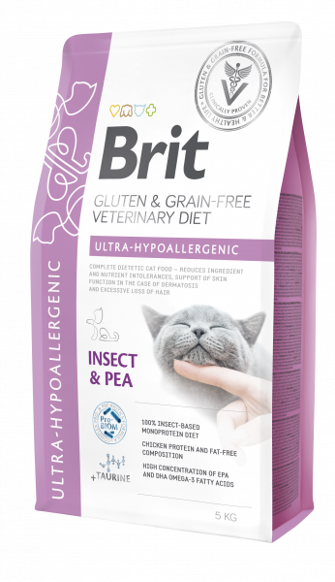
5 kg & 2 kg & 0.4 kg

GASTROINTESTINAL-LOW FAT
COMPLETE DIETETIC FOOD FOR CATS WITH LOWER CALORIES FOR CATS PRONE TO OBESITY, LIPID ABSORPTION DISORDER, AND TRIADITIS.

INDICATIONS
- EASILY DIGESTIBLE PROTEINS OF HIGH BIOLOGICAL VALUE AND LOW FAT CONTENT
- REDUCE RISK OF GAINING WEIGHT, AND SYMPTOMS OF LIPID ABSORBTION DISORDERS
- NO RISK OF ALLERGY/INTOLERANCE TO GLUTEN OR CHICKEN PROTEIN
- SUPPORTS THE INTESTINAL MICROBIOME AND IMMUNE SYSTEM

BENEFITS
- EASILY DIGESTIBLE PROTEINS OF HIGH BIOLOGICAL VALUE AND LOW FAT CONTENT
- REDUCE RISK OF GAINING WEIGHT, AND SYMPTOMS OF LIPID ABSORBTION DISORDERS
- NO RISK OF ALLERGY/INTOLERANCE TO GLUTEN OR CHICKEN PROTEIN
- SUPPORTS THE INTESTINAL MICROBIOME AND IMMUNE SYSTEM

COMPOSITION:
yellow peas (30%), dehydrated herring (26%), buckwheat, hydrolysed salmon protein (10%), eggs (4%), dried apple pulp, salmon oil (3%), hydrolysed salmon gravy (2%), sodium chloride, egg shells (a source of calcium), psyllium husks and seeds (1%), brewer´s yeast (1%), pea flour, dried algae (0.5%, Ascophyllum nodosum), potassium chloride, yeast extract (source of mannan-oligosaccharides, 0.025%), β-glucans (0.022%), fructo-oligosaccharides (0.02%), Mojave yucca (0.02%), dried sea buckthorn (0.015%), Lactobacillus helveticus HA – 122 inactivated (15x109 cells/kg).

METABOLISABLE ENERGY:
3,490 kcal/kg.

ANALYTICAL CONSTITUENTS:
vitamin A (3a672a) 25,000 IU, vitamin D3 (3a671) 850 IU, vitamin E (3a700) 1,000 mg, vitamin C (3a312) 300 mg, choline chloride (3a890) 2,300 mg, biotin (3a880) 3 mg, vitamin B1 (3a821) 10 mg, vitamin B2 (3a825i) 50 mg, niacinamide (3a315) 80 mg, calcium-D-pantothenate (3a841) 50 mg, vitamin B6 (3a831) 35 mg, folic acid (3a316) 15 mg, vitamin B12 0.18 mg, zinc (3b606) 120 mg, iron (3b106) 60 mg, manganese (3b504) 60 mg, iodine (3b201) 4 mg, copper (3b406) 3.5 mg, selenium (3b810) 0.2 mg, taurine (3a370) 2,300 mg. L-carnitine (3a910) 240 mg, L-methionine (3c305) 4,000 mg.

NUTRITIONAL ADDITIVES PER 1 KG:
crude protein 32.0 %, crude fat 8.0 %, crude fibre 1.8 %, crude ash 7.2 %, moisture 10.0 %, total sugars (as NFE) 42.2 %, omega-3 fatty acids 1.3 %, omega-6 fatty acids 0.6 %, calcium 1.0 %, phosphorus 0.7 %, sodium 0.5 %, magnesium 0.1 %, potassium 0.8 %.
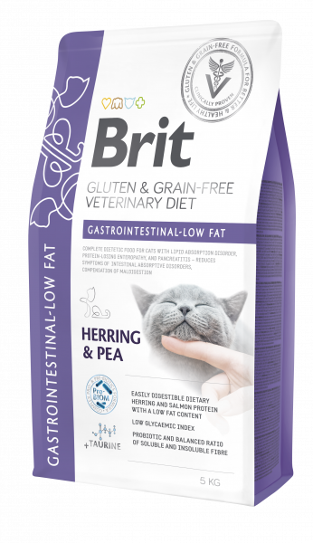
5 kg & 2 kg & 0.4 kg

STERILISED
COMPLETE FOOD FOR STERILISED ADULT CATS OF ALL BREEDS

INDICATIONS
- WEIGHT CONTROL IN STERILISED CATS
- BODY CONDITION SUPPORT IN STERILISED C ATS
- SUPPORT OF HEALTHY SKIN AND COAT & URINARY TRACT

BENEFITS
- WEIGHT CONTROL AND CONDITION SUPPORT IN STERILISED DOGS
- NUTRITIONAL SUPPORT OF SKIN AND COAT AND URINARY TRACT HEALTH
- STRENGTHENING OF THE NATURAL SKIN BARRIER AND IMMUNITY NO RISK OF ALLERGY/INTOLERANCE TO GLUTEN OR CHICKEN PROTEIN
- SUPPORTS THE INTESTINAL MICROBIOME AND IMMUNE SYSTEM

COMPOSITION:
dehydrated salmon (30%), yellow peas, hydrolysed salmon protein (14%), pea protein, coconut oil, dried apple pulp, lignocellulose (2%), salmon oil (3%), hydrolyzed salmon (2%), sodium chloride, potassium chloride, psyllium husk & seeds (1%), pea flour, dried Vaccinium vitis-idaea (0.2%), dried Urtica dioica (0.12%), dried Carlina acaulis (0.08%), hydrolysed crustacean shells (a source of glucosamine sulphate, 0.036%), hydrolysed cartilage (a source of chondroitin sulphate, 0.025%), yeast extract (source of mannan-oligosaccharides, 0.02%), β-glucans (0.02%), dried sea buckthorn (0.015%), fructo-oligosaccharides (0.013%), Mojave yucca (0.012%), Lactobacillus helveticus HA – 122 inactivated (15x109 cells/kg).

METABOLISABLE ENERGY:
3,600 kcal/kg.

ANALYTICAL CONSTITUENTS:
crude protein 33.0 %, crude fat 12.0 %, crude fibre 3.0 %, crude ash 8.2 %, moisture 10.0 %, omega-3 fatty acids 1.0 %, omega-6 fatty acids 0.8 %, calcium 1.0 %, phosphorus 0.7 %, sodium 1.1 %, potassium 0.6 %, magnesium 0.05 %.

NUTRITIONAL ADDITIVES PER 1 KG:
vitamin A (3a672a) 24,000 IU, vitamin D₃ (3a671) 850 IU, vitamin E (3a700) 1,000 mg, vitamin C (3a312) 300 mg, choline chloride (3a890) 2,300 mg, biotin (3a880) 3 mg, vitamin B₁ (3a821) 10 mg, vitamin B₂ (3a825i) 30 mg, niacinamide (3a315) 60 mg, calcium-D-pantothenate (3a841) 50 mg, vitamin B₆ (3a831) 35 mg, folic acid (3a316) 15 mg, vitamin B12 0.15 mg, zinc (3b606) 110 mg, iron (3b106) 55 mg, manganese (3b504) 35 mg, iodine (3b201) 3 mg, copper (3b406) 3 mg, selenium (3b810) 0.2 mg, taurine (3a370) 2,300 mg, L-carnitine (3a910) 600 mg, L-methionine (3c305) 6,000 mg.
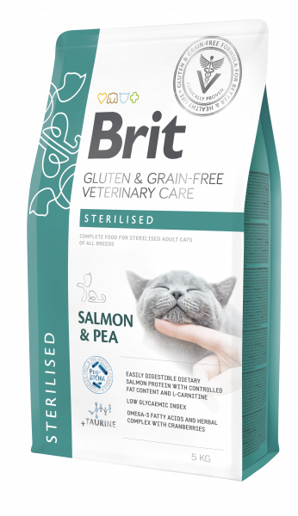
5 kg & 2 kg & 0.4 kg

calm & stress relief
complete dietetic cat food for reduction of stress related disorders and calming support in stressful situations

indications
- nutritional support of stress related disorders
- prevention of struvite and oxalate formation
- calming support in stressful situations

benefits
- reduces occurrence of stress-related urinary disorders, anxiety, and behavioural disorders
- reduced risk of struvite and oxalate formation
- nutritional support for lower urinary tract inflammation
- supports the intestinal microbiome and immune system

COMPOSITION:
yellow peas, dehydrated salmon (26%), pea protein, hydrolyzed poultry protein (10%), whey (5%), lignocellulose, chicken fat, hydrolyzed chicken liver, salmon oil (2%), psyllium husk & seeds (1%), calcium sulphate (0.7%, urine acidifying substance), yeast extract (source of mannan-oligosaccharides, 0.022%), β-glucans (0.02%), fructo-oligosaccharides (0.02%), Mojave yucca (0.02%), dried sea buckthorn (0.015%), Lactobacillus helveticus HA – 122 inactivated (15x109 cells/kg).

METABOLISABLE ENERGY:
3,520 kcal/kg.

ANALYTICAL CONSTITUENTS:
crude protein 36.0 %, crude fat 11.0 %, crude fibre 4.0 %, crude ash 8.4 %, moisture 10.0, omega-3 fatty acids 1.0 %, omega-6 fatty acids 1.3 %, calcium 1.0 %, phosphorus 0.8 %, sodium 1.3 %, magnesium 0.06 %, potassium 0.6 %, chlorides 1.8 %, sulphur 0.6 %, taurine 0.23 %, hydroxyproline 0.4 %, vitamin D 500 IU/kg, methionine 1.0 %.

NUTRITIONAL ADDITIVES PER 1 KG:
: vitamin A (3a672a) 25,000 IU, vitamin D₃ (3a671) 500 IU, vitamin E (3a700) 1,000 mg, choline chloride (3a890) 2,300 mg, biotin (3a880) 3 mg, vitamin B₁ (3a821) 10 mg, vitamin B₂ (3a825i) 30 mg, niacinamide (3a315) 100 mg, calcium-D-pantothenate (3a841) 60 mg, vitamin B₆ (3a831) 35 mg, folic acid (3a316) 15 mg, vitamin B12 0.18 mg, zinc (3b606) 120 mg, iron (3b106) 60 mg, manganese (3b504) 60 mg, iodine (3b201) 4 mg, copper (3b406) 3.5 mg, selenium (3b810) 0.2 mg, taurine (3a370) 2,300 mg, L-carnitine (3a910) 230 mg, L-methionine (3c305) 4,000 mg, L-tryptophan (3c440) 4,400 mg.
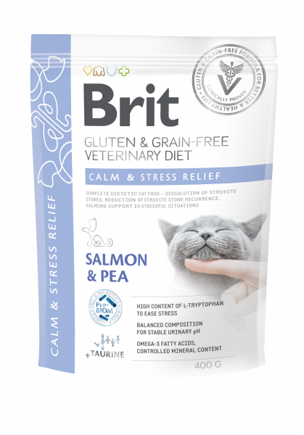
5 kg & 2 kg & 0.4 kg

