Product name: Brit Premium by Nature Beef with Tripe
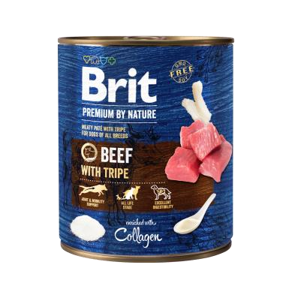
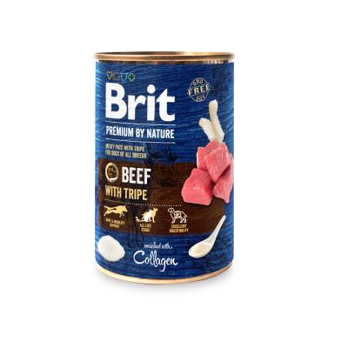
Complete food for adult dog of all breeds. Meaty paté with tripe for dogs.

Package: 400 g, 800 g
Composition: beef 36%, beef broth 35.5%, chicken 22%, tripe 4%, collagen 1%, minerals 1%, salmon oil 0.5%.
Feeding guide: The daily nutritional requirements of your dog may vary according to environment, size, age, and activity level. Serve the can at room temperature. When serving for increased variety and flavour, be sure to reduce the recommended daily serving size of your dog´s regular food accordingly. Fresh water must be available at all times. Store in a cool and dry place. Once the can is opened, keep in the fridge. Expiry date and batch on the can bottom.

Feeding table:
Dog Size/Daily Amount | As complete food | As complementary food, 50% of daily intake | As complementary food, 25% of daily intake
Small (1-10 kg) | 200 – 400 g | 100 – 200 g | 50 – 100 g
Medium (10-25 kg) | 400 – 800 g | 200 – 400 | 100 – 200 g
Large (25-50 kg) | 800 – 1200 g | 400 – 600 g | 200 – 300 g
Extra Large (50-70 kg) | 1200 – 1600 g | 600 – 800 g | 300 – 400 g

Analytical constituents:
crude protein | 9.0 | %
crude fat | 6.5 | %
crude fibers | 0.4 | %
crude ash | 2.7 | %
moisture | 78.0 | %
calcium | 0.3 | %
phosphorus | 0.3 | %
sodium | 0.5 | %
Nutritional additives per 1 kg:
vitamin D3 (E671) | 200 | IU
vitamin E (3a700) | 100 | mg
zinc (3b606) | 10 | mg
iron (3b103) | 8 | mg
manganese (3b502) | 2 | mg
iodine (3b201) | 0.5 | mg
copper (3b405) | 0.5 | mg

Metabolizable energy: 1 065 kcal/kg

Store in a cool and dry place. Once the can is opened, keep in the fridge
-05,
Product name: Brit Premium by Nature Fish with Fish Skin
Complete food for adult dogs of all breeds. Meaty paté with fish skin for dogs.

Package: 400 g, 800 g
Composition: Fish 36%, fish broth 35.5%, chicken 22%, fish skin 4%, salmon oil 1.5%, minerals 1%.

Feeding guide: The daily nutritional requirements of your dog may vary according to environment, size, age, and activity level. Serve the can at room temperature. When serving for increased variety and flavour, be sure to reduce the recommended daily serving size of your dog´s regular food accordingly. Fresh water must be available at all times. Store in a cool and dry place. Once the can is opened, keep in the fridge. Expiry date and batch on the can bottom.

Feeding table:
Dog Size/Daily Amount | As complete food | As complementary food, 50% of daily intake | As complementary food, 25% of daily intake
Small (1-10 kg) | 200 – 400 g | 100 – 200 g | 50 – 100 g
Medium (10-25 kg) | 400 – 800 g | 200 – 400 | 100 – 200 g
Large (25-50 kg) | 800 – 1200 g | 400 – 600 g | 200 – 300 g
Extra Large (50-70 kg) | 1200 – 1600 g | 600 – 800 g | 300 – 400 g

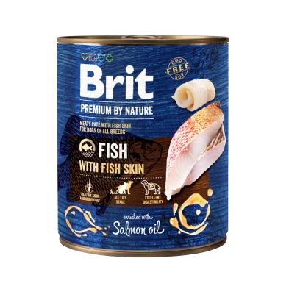
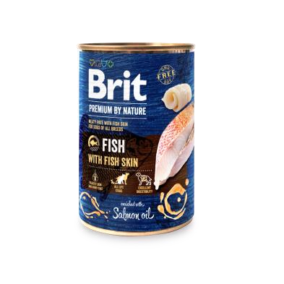
Analytical constituents:

crude protein | 8.5 | %
crude fat | 5.0 | %
crude fibers | 0.3 | %
crude ash | 2.8 | %
moisture | 78.0 | %
calcium | 0.3 | %
phosphorus | 0.3 | %
sodium | 0.5 | %
Nutritional additives per 1 kg:
vitamin D3 (E671) | 200 | IU
vitamin E (3a700) | 100 | mg
zinc (3b606) | 10 | mg
iron (3b103) | 8 | mg
manganese (3b502) | 2 | mg
iodine (3b201) | 0.5 | mg
copper (3b405) | 0.5 | mg

Metabolizable energy: 1 000 kcal/kg
Store in a cool and dry place. Once the can is opened, keep in the fridge Expiry date and batch on the can bottom.

Producer: VAFO PRAHA s.r.o., K Brůdku 94, Chrášťany 252 19, Czech Republic. Reg.No.: CZ800175-05, Export No.: CZ31712936, www.brit-petfood.com

Product name: Brit Premium by Nature Chicken with Hearts
Complete food for adult dog of all breeds. Meaty paté with chicken hearts for dogs.
Package: 400 g, 800 g
Composition: chicken 58%, chicken broth 35.5%, chicken hearts 4%, blueberries 1%, minerals 1%, salmon oil 0.5%.

Feeding guide: The daily nutritional requirements of your dog may vary according to environment, size, age, and activity level. Serve the can at room temperature. When serving for increased variety and flavour, be sure to reduce the recommended daily serving size of your dog´s regular food accordingly. Fresh water must be available at all times. Store in a cool and dry place. Once the can is opened, keep in the fridge. Expiry date and batch on the can bottom.

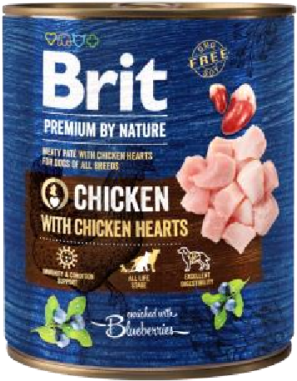
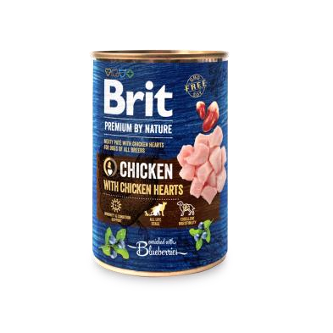
Feeding table:

Dog Size/Daily Amount | As complete food | As complementary food, 50% of daily intake | As complementary food, 25% of daily intake
Small (1-10 kg) | 200 – 400 g | 100 – 200 g | 50 – 100 g
Medium (10-25 kg) | 400 – 800 g | 200 – 400 | 100 – 200 g
Large (25-50 kg) | 800 – 1200 g | 400 – 600 g | 200 – 300 g
Extra Large (50-70 kg) | 1200 – 1600 g | 600 – 800 g | 300 – 400 g

Analytical constituents:
crude protein | 8.0 | %
crude fat | 6.0 | %
crude fibers | 0.4 | %
crude ash | 2.9 | %
moisture | 78.0 | %
calcium | 0.3 | %
phosphorus | 0.3 | %
sodium | 0.5 | %
Nutritional additives per 1 kg:
vitamin D3 (E671) | 200 | IU
vitamin E (3a700) | 100 | mg
zinc (3b606) | 10 | mg
iron (3b103) | 8 | mg
manganese (3b502) | 2 | mg
iodine (3b201) | 0.5 | mg
copper (3b405) | 0.5 | mg

Metabolizable energy: 1 030 kcal/kg

Product name: Brit Premium by Nature Lamb with Buckwheat
Complete food for adult dog of all breeds. Meaty paté for SENSITIVE dogs.
Package: 400 g, 800 g
Composition: lamb 36%, lamb broth 35.5%, chicken 22%, buckwheat 4%, apple 1%, minerals 1%, salmon oil 0.5%.

Feeding guide: The daily nutritional requirements of your dog may vary according to environment, size, age, and activity level. Serve the can at room temperature. When serving for increased variety and flavour, be sure to reduce the recommended daily serving size of your dog´s regular food accordingly. Fresh water must be available at all times. Store in a cool and dry place. Once the can is opened, keep in the fridge. Expiry date and batch on the can bottom.

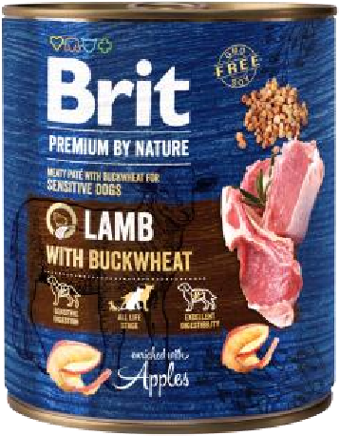
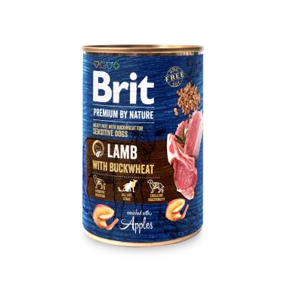
Feeding table:

Dog Size/Daily Amount | As complete food | As complementary food, 50% of daily intake | As complementary food, 25% of daily intake
Small (1-10 kg) | 200 – 400 g | 100 – 200 g | 50 – 100 g
Medium (10-25 kg) | 400 – 800 g | 200 – 400 | 100 – 200 g
Large (25-50 kg) | 800 – 1200 g | 400 – 600 g | 200 – 300 g
Extra Large (50-70 kg) | 1200 – 1600 g | 600 – 800 g | 300 – 400 g

Analytical constituents:
crude protein | 8.0 | %
crude fat | 5.0 | %
crude fibers | 0.3 | %
crude ash | 2.7 | %
moisture | 78.0 | %
calcium | 0.3 | %
phosphorus | 0.3 | %
sodium | 0.5 | %
Nutritional additives per 1 kg:
vitamin D3 (E671) | 200 | IU
vitamin E (3a700) | 100 | mg
zinc (3b606) | 10 | mg
iron (3b103) | 8 | mg
manganese (3b502) | 2 | mg
iodine (3b201) | 0.5 | mg
copper (3b405) | 0.5 | mg

Metabolizable energy: 1 000 kcal/kg

Product name: Brit Premium by Nature Pork with Trachea
Complete food for adult dog of all breeds. Meaty paté with trachea for dogs.
Package: 400 g, 800 g
Composition: pork 36%, pork broth 35.5%, chicken 21%, pork trachea 5%, rosemary 1%, minerals 1%, salmon oil 0.5%.

Feeding guide: The daily nutritional requirements of your dog may vary according to environment, size, age, and activity level. Serve the can at room temperature. When serving for increased variety and flavour, be sure to reduce the recommended daily serving size of your dog´s regular food accordingly. Fresh water must be available at all times. Store in a cool and dry place. Once the can is opened, keep in the fridge. Expiry date and batch on the can bottom.

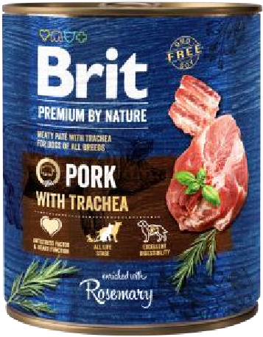
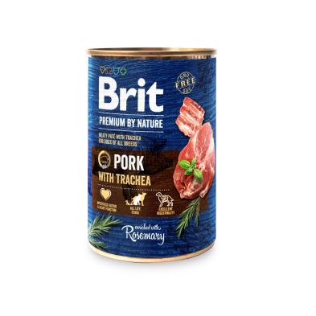
Feeding table:

Dog Size/Daily Amount | As complete food | As complementary food, 50% of daily intake | As complementary food, 25% of daily intake
Small (1-10 kg) | 200 – 400 g | 100 – 200 g | 50 – 100 g
Medium (10-25 kg) | 400 – 800 g | 200 – 400 | 100 – 200 g
Large (25-50 kg) | 800 – 1200 g | 400 – 600 g | 200 – 300 g
Extra Large (50-70 kg) | 1200 – 1600 g | 600 – 800 g | 300 – 400 g

Analytical constituents:
crude protein | 8.5 | %
crude fat | 5.5 | %
crude fibers | 0.3 | %
crude ash | 2.7 | %
moisture | 78.0 | %
calcium | 0.3 | %
phosphorus | 0.3 | %
sodium | 0.5 | %
Nutritional additives per 1 kg:
vitamin D3 (E671) | 200 | IU
vitamin E (3a700) | 100 | mg
zinc (3b606) | 10 | mg
iron (3b103) | 8 | mg
manganese (3b502) | 2 | mg
iodine (3b201) | 0.5 | mg
copper (3b405) | 0.5 | mg

Metabolizable energy: 1 020 kcal/kg

Product name: Brit Premium by Nature Turkey with Liver
Complete food for JUNIOR dog of all breeds. Meaty paté with liver for dogs.
Package: 400 g, 800 g
Composition: turkey 36%, turkey broth 35.5%, chicken 22%, turkey liver 4%, chamomile 1%, minerals 1%, salmon oil 0.5%.

Feeding guide: The daily nutritional requirements of your dog may vary according to environment, size, age, and activity level. Serve the can at room temperature. When serving for increased variety and flavour, be sure to reduce the recommended daily serving size of your dog´s regular food accordingly. Fresh water must be available at all times. Store in a cool and dry place. Once the can is opened, keep in the fridge. Expiry date and batch on the can bottom.

Feeding table:
Age (months) | Body weight of adult dog (kg) | Small (1-10kg) | Medium (10-25kg) | Large (25-45kg) | Extra Large (45-90kg)
1 - 3 | Daily amount (g) | 50 - 100 | 100 - 200 | 400 - 500 | 600 - 800
3 - 6 | Daily amount (g) | 100 – 150 | 200 – 300 | 500 - 600 | 800 – 1000
6 - 12 | Daily amount (g) | 150 - 200 | 300 – 400 | 600 - 800 | 1000 - 1200

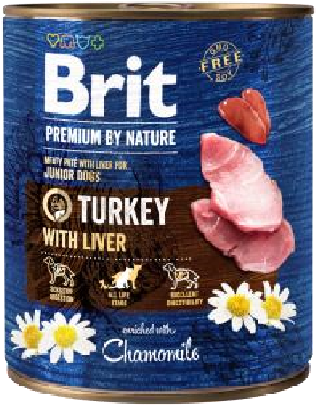
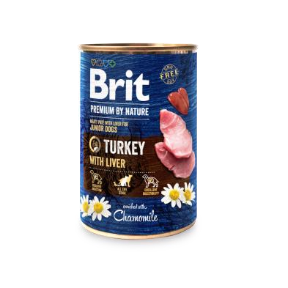
Analytical constituents:

crude protein | 8.0 | %
crude fat | 5.5 | %
crude fibers | 0.4 | %
crude ash | 2.8 | %
moisture | 78.0 | %
calcium | 0.3 | %
phosphorus | 0.3 | %
sodium | 0.5 | %
Nutritional additives per 1 kg:
vitamin D3 (E671) | 200 | IU
vitamin E (3a700) | 100 | mg
zinc (3b606) | 10 | mg
iron (3b103) | 8 | mg
manganese (3b502) | 2 | mg
iodine (3b201) | 0.5 | mg
copper (3b405) | 0.5 | mg

Metabolizable energy: 1 010 kcal/kg

Store in a cool and dry place. Once the can is opened, keep in the fridge Expiry date and batch on the can bottom.

Producer: VAFO PRAHA s.r.o., K Brůdku 94, Chrášťany 252 19, Czech Republic. Reg.No.: CZ800175-05, Export No.: CZ31712936, www.brit-petfood.com

