Brit Raw Treat Urinary. Freeze-Dried Cat Treat and Topper.
Chicken & Turkey with Probiotics and Cranberry

- Raw Freeze Dried: 96% FRESH meat
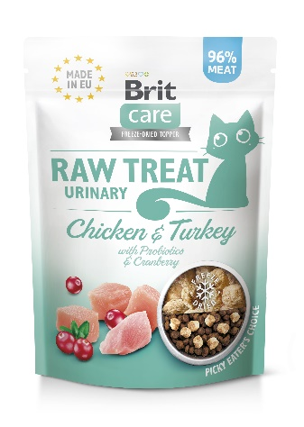
- Natural
- NO artificial preservatives, flavours, colourants, added salt
- Hydrolyzed yeast: provide essential nutrients and maintains proper gut health
- Lactobacillus: inactivated, immunomodulatory effect

Complementary cat food for adult sterilized cats

Package: 40 g

Composition: fresh chicken trimmings (70%), fresh turkey trimmings (26%), lignocellulose (2%), cranberries (1%), hydrolyzed yeast (0.5%, source of inositol and amino acids), inactivated bacteria and parts thereof (Lactobacillus helveticus HA – 122, 15x10⁹ cells/kg).

Feeding guide: Freeze-Dried RAW TREAT is formulated to complement, not substitute, a complete and balanced diet. Serve approx. 2 pcs per 1 kg of cat weight, but do not exceed 10% of your cat’s daily food intake. If the treats are too big for your cat, crumble them before serving. Crumble 5–10 treats on top of your cat’s regular food as an appetizer. Make sure your cat always has plenty of fresh drinking water.

Analytical constituents:
crude protein | 42.0 | %
crude fat | 35.0 | %
moisture | 4.0 | %
crude ash | 10.0 | %
crude fibre | 2.5 | %
calcium | 3.0 | %
phosphorus | 2.0 | %
sodium | 1.0 | %

Contains natural antioxidants: tocopherol extracts from vegetable oil (1b306(i)), ascorbyl palmitate (1b304).
Contains EU approved preservatives: citric acid (1a330).

Metabolizable energy: 4,870 kcal/kg

Keep in a dry, cool place away from direct sunlight. Reseal after opening. See back of bag for best before date, batch code, and manufacturer registration number.

Produced by:
Vafo Group
Pandivere L.T. OÜ
Reg. no. 10294126
Approval no. 07/ABP/LE01

Brit Raw Treat Sensitive. Freeze-Dried Cat Treat and Topper.
Turkey with Probiotics and Chamomile

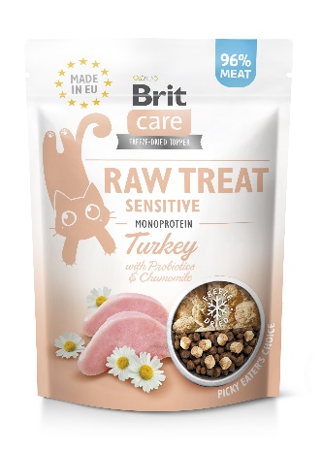
- Raw Freeze Dried: 96% FRESH meat
- Monoprotein
- Natural
- NO artificial preservatives, flavours, colourants, added salt
- Hydrolyzed yeast: provide essential nutrients and maintains proper gut health
- Lactobacillus: inactivated, immunomodulatory effect

Complementary cat food for adult cats

Package: 40 g

Composition: fresh turkey trimmings (96%), lignocellulose (2%), dried chamomile (0,5%), hydrolyzed yeast (0.5%, source of inositol and amino acids), inactivated bacteria and parts thereof (Lactobacillus helveticus HA – 122, 15x10⁹ cells/kg).

Feeding guide: Freeze-Dried RAW TREAT is formulated to complement, not substitute, a complete and balanced diet. Serve approx. 2 pcs per 1 kg of cat weight, but do not exceed 10% of your cat’s daily food intake. If the treats are too big for your cat, crumble them before serving. Crumble 5–10 treats on top of your cat’s regular food as an appetizer. Make sure your cat always has plenty of fresh drinking water.

Analytical constituents:
crude protein | 43.0 | %
crude fat | 37.0 | %
moisture | 4.0 | %
crude ash | 10.0 | %
crude fibre | 2.5 | %
calcium | 3.0 | %
phosphorus | 2.0 | %
sodium | 1.0 | %

Contains natural antioxidants: tocopherol extracts from vegetable oil (1b306(i)), ascorbyl palmitate (1b304).
Contains EU approved preservatives: citric acid (1a330).

Metabolizable energy: 4,960 kcal/kg

Keep in a dry, cool place away from direct sunlight. Reseal after opening. See back of bag for best before date, batch code, and manufacturer registration number.

Produced by:
Vafo Group
Pandivere L.T. OÜ
Reg. no. 10294126
Approval no. 07/ABP/LE01

Brit Raw Treat Indoor & Antistress. Freeze-Dried Cat Treat and Topper.
Chicken with Probiotics and Motherwort

- Raw Freeze Dried: 96% FRESH meat
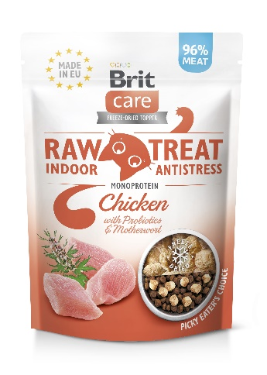
- Monoprotein
- Natural
- NO artificial preservatives, flavours, colourants, added salt
- Hydrolyzed yeast: provide essential nutrients and maintains proper gut health
- Lactobacillus: inactivated, immunomodulatory effect

Complementary cat food for adult cats

Package: 40 g

Composition: fresh chicken trimmings (96%), lignocellulose (2%), dried motherwort (0,5%), hydrolyzed yeast (0.5%, source of inositol and amino acids), inactivated bacteria and parts thereof (Lactobacillus helveticus HA – 122, 15x10⁹ cells/kg).

Feeding guide: Freeze-Dried RAW TREAT is formulated to complement, not substitute, a complete and balanced diet. Serve approx. 2 pcs per 1 kg of cat weight, but do not exceed 10% of your cat’s daily food intake. If the treats are too big for your cat, crumble them before serving. Crumble 5–10 treats on top of your cat’s regular food as an appetizer. Make sure your cat always has plenty of fresh drinking water.

Analytical constituents:
crude protein | 43.0 | %
crude fat | 37.0 | %
moisture | 4.0 | %
crude ash | 10.0 | %
crude fibre | 2.5 | %
calcium | 3.0 | %
phosphorus | 2.0 | %
sodium | 1.0 | %

Contains natural antioxidants: tocopherol extracts from vegetable oil (1b306(i)), ascorbyl palmitate (1b304).
Contains EU approved preservatives: citric acid (1a330).

Metabolizable energy: 4,960 kcal/kg

Keep in a dry, cool place away from direct sunlight. Reseal after opening. See back of bag for best before date, batch code, and manufacturer registration number.

Produced by:
Vafo Group
Pandivere L.T. OÜ
Reg. no. 10294126
Approval no. 07/ABP/LE01

Brit Raw Treat Hair & Skin. Freeze-Dried Cat Treat and Topper.
Fish & Turkey with Probiotics and Sea Buckthorn

- Raw Freeze Dried: 96% FRESH meat & fish
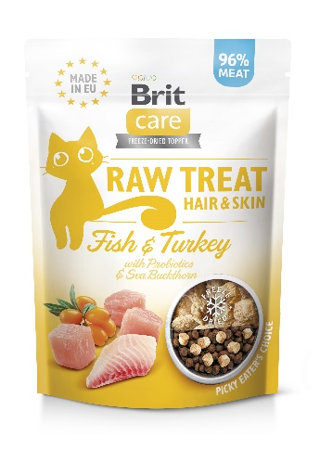
- Natural
- NO artificial preservatives, flavours, colourants, added salt
- Hydrolyzed yeast: provide essential nutrients and maintains proper gut health
- Lactobacillus: inactivated, immunomodulatory effect

Complementary cat food for adult cats

Package: 40 g

Composition: fresh turkey trimmings (70%), fresh salmon trimmings (26%), lignocellulose (2%), dried sea buckthorn (0,5%), hydrolyzed yeast (0.5%, source of inositol and amino acids), inactivated bacteria and parts thereof (Lactobacillus helveticus HA – 122, 15x10⁹ cells/kg).

Feeding guide: Freeze-Dried RAW TREAT is formulated to complement, not substitute, a complete and balanced diet. Serve approx. 2 pcs per 1 kg of cat weight, but do not exceed 10% of your cat’s daily food intake. If the treats are too big for your cat, crumble them before serving. Crumble 5–10 treats on top of your cat’s regular food as an appetizer. Make sure your cat always has plenty of fresh drinking water.

Analytical constituents:
crude protein | 43.0 | %
crude fat | 37.0 | %
moisture | 4.0 | %
crude ash | 10.0 | %
crude fibre | 2.5 | %
calcium | 3.0 | %
phosphorus | 2.0 | %
sodium | 1.0 | %
Contains natural antioxidants: tocopherol extracts from vegetable oil (1b306(i)), ascorbyl palmitate (1b304).
Contains EU approved preservatives: citric acid (1a330).

Metabolizable energy: 4,960 kcal/kg

Keep in a dry, cool place away from direct sunlight. Reseal after opening. See back of bag for best before date, batch code, and manufacturer registration number.

Produced by:
Vafo Group
Pandivere L.T. OÜ
Reg. no. 10294126
Approval no. 07/ABP/LE01

Brit Raw Treat Kitten. Freeze-Dried Cat Treat and Topper.
Chicken & Salmon with Probiotics, Whey, and Omega-3

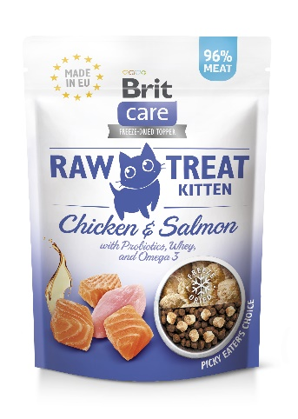
- Raw Freeze Dried: 96% FRESH meat & fish
- Salmon: source of omega-3 fatty acid
- Natural
- NO artificial preservatives, flavours, colourants, added salt
- Hydrolyzed yeast: supports growth and maintains proper gut health
- Lactobacillus: inactivated, immunomodulatory effect

Complementary cat food for kittens

Package: 40 g

Composition: fresh chicken trimmings (70%), fresh salmon trimmings (26%), lignocellulose (2%), whey (0,5%), hydrolyzed yeasts (0.5% - a source of inositol and amino acids), inactivated bacteria and parts thereof (Lactobacillus helveticus HA – 122, 15x10⁹ cells/kg).

Feeding guide: Freeze-Dried RAW TREAT is formulated to complement, not substitute, a complete and balanced diet. Serve approx. 2 pcs per 1 kg of cat weight, but do not exceed 10% of your cat’s daily food intake. If the treats are too big for your cat, crumble them before serving. Crumble 5–10 treats on top of your cat’s regular food as an appetizer. Make sure your cat always has plenty of fresh drinking water.

Analytical constituents:
crude protein | 43.0 | %
crude fat | 37.0 | %
moisture | 4.0 | %
crude ash | 10.0 | %
crude fibre | 2.5 | %
calcium | 3.0 | %
phosphorus | 2.0 | %
sodium | 1.0 | %

Contains natural antioxidants: tocopherol extracts from vegetable oil (1b306(i)), ascorbyl palmitate (1b304).
Contains EU approved preservatives: citric acid (1a330).

Metabolizable energy: 4,960 kcal/kg

Keep in a dry, cool place away from direct sunlight. Reseal after opening. See back of bag for best before date, batch code, and manufacturer registration number.

Produced by:
Vafo Group
Pandivere L.T. OÜ
Reg. no. 10294126
Approval no. 07/ABP/LE01

