BCC pouches NEW

Brit Care Cat Sterilized.
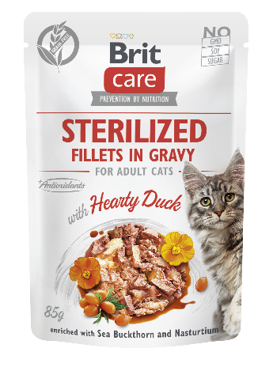
Fillets in Gravy with Hearty Duck Enriched with Sea Buckthorn and Nasturtium.

Complete Superpremium Grain-Free Wet Cat Food for Adult Sterilized Cats.

- No GMO/soy/sugar
- L-methionine / Urine pH control support

Package: 85 g

Composition: fillets with 85% meat (62% chicken, 15% liver, 8% duck), lignocellulose, 1% dried sea buckthorn, 0.5% dried nasturtium, calcium carbonate, pea flour.

Feeding guide: The recommended daily allowance is shown in the feeding table but may vary depending on your cat’s age, activity level, and enviroment. Always provide a bowl of fresh water. Serve at room temperature. When serving for increased variety and flavour, be sure to reduce the recommended daily serving size of your cat’s regular food accordingly. Keep in fridge after opening.

Feeding table:
Weight of cat (kg) | 3 | 4–6 | 6–8
Pouches per day | 2 | 3–4 | 4–6

Analytical constituents:
crude protein | 7.0 | %
crude fat | 3.2 | %
crude fibre | 0.5 | %
crude ash | 2.2 | %
moisture | 82.0 | %
calcium | 0.2 | %
phosphorus | 0.2 | %
sodium | 0.25 | %
Nutritional additives per 1 kg:
vitamin A (3a672a) | 400 | IU
vitamin D₃ (3a671) | 100 | IU
vitamin E (3a700) | 50 | mg
choline chloride (3a890) | 60 | mg
vitamin B₁ (3a821) | 0.3 | mg
biotin (3a880) | 0.1 | mg
zinc (3b606) | 3.5 | mg
manganese (3b502) | 0.8 | mg
iron (3b103) | 2.8 | mg
iodine (3b201) | 0.2 | mg
taurine (3a370) | 500 | mg
L-methionine (3c305) | 1 750 | mg

Contains EU approved natural antioxidants: tocopherol extracts from vegetable oil (1b306(i)), ascorbyl palmitate (1b304) & rosemary extract.

Keep in a dry and cool place away from direct sunlight. Expiry date 24 months from production date, batch printed on package.

Metabolizable energy: 760 kcal/kg

Producer: VAFO Production s.r.o., Produced for: VAFO PRAHA s.r.o., K Brůdku 94, Chrášťany 252 19, Czech Republic. Registration No.: CZ800175-05, Export No.: CZ31712936

BCC pouches NEW

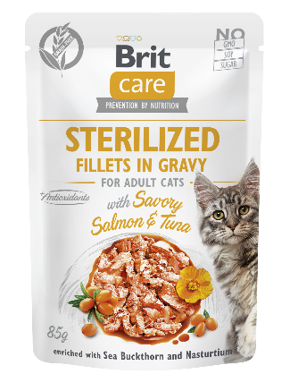
Brit Care Cat Sterilized.

Fillets in Gravy with Savory Salmon&Tuna Enriched with Sea Buckthorn and Nasturtium.

Complete Superpremium Grain-Free Wet Food for Adult Sterilized Cats.

- No GMO/soy/sugar
- L-methionine / Urine pH control support

Package: 85 g

Composition: fillets with 85% meat (62% chicken, 15% liver, 4% tuna, 4% salmon), lignocellulose, 1% dried sea buckthorn, 0.5% dried nasturtium, calcium carbonate, pea flour.

Feeding guide: The recommended daily allowance is shown in the feeding table but may vary depending on your cat’s age, activity level, and enviroment. Always provide a bowl of fresh water. Serve at room temperature. When serving for increased variety and flavour, be sure to reduce the recommended daily serving size of your cat’s regular food accordingly. Keep in fridge after opening.

Feeding table:
Weight of cat (kg) | 3 | 4–6 | 6–8
Pouches per day | 2 | 3–4 | 4–6

Analytical constituents:
crude protein | 7.0 | %
crude fat | 3.5 | %
crude fibre | 0.5 | %
crude ash | 2.3 | %
moisture | 82.0 | %
calcium | 0.2 | %
phosphorus | 0.2 | %
sodium | 0.25 | %
Nutritional additives per 1 kg:
vitamin A (3a672a) | 400 | IU
vitamin D₃ (3a671) | 100 | IU
vitamin E (3a700) | 50 | mg
choline chloride (3a890) | 60 | mg
vitamin B₁ (3a821) | 0.3 | mg
biotin (3a880) | 0.1 | mg
zinc (3b606) | 3.5 | mg
manganese (3b502) | 0.8 | mg
iron (3b103) | 2.8 | mg
iodine (3b201) | 0.2 | mg
taurine (3a370) | 500 | mg
L-methionine (3c305) | 1 750 | mg

Contains EU approved natural antioxidants: tocopherol extracts from vegetable oil (1b306(i)), ascorbyl palmitate (1b304) & rosemary extract.

Keep in a dry and cool place away from direct sunlight. Expiry date 24 months from production date, batch printed on package.

Metabolizable energy: 770 kcal/kg

Producer: VAFO Production s.r.o., Produced for: VAFO PRAHA s.r.o., K Brůdku 94, Chrášťany 252 19, Czech Republic. Registration No.: CZ800175-05, Export No.: CZ31712936

BCC pouches NEW

Brit Care Cat Sterilized.
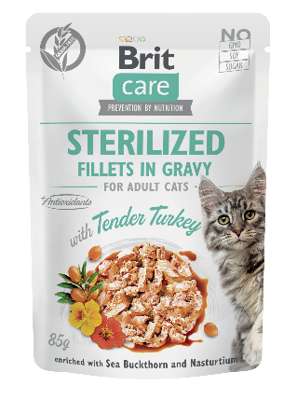
Fillets in Gravy with Tender Turkey Enriched with Sea Buckthorn and Nasturtium.

Complete Superpremium Grain-Free Wet Food for Adult Sterilized Cats.

- No GMO/soy/sugar
- L-methionine / Urine pH control support

Package: 85 g

Composition: fillets with 85% meat (62% chicken, 15% liver, 8% turkey), lignocellulose, 1% dried sea buckthorn, 0.5% dried nasturtium, calcium carbonate, pea flour.

Feeding guide: The recommended daily allowance is shown in the feeding table but may vary depending on your cat’s age, activity level, and enviroment. Always provide a bowl of fresh water. Serve at room temperature. When serving for increased variety and flavour, be sure to reduce the recommended daily serving size of your cat’s regular food accordingly. Keep in fridge after opening.

Feeding table:
Weight of cat (kg) | 3 | 4–6 | 6–8
Pouches per day | 2 | 3–4 | 4–6

Analytical constituents:
crude protein | 7.0 | %
crude fat | 3.0 | %
crude fibre | 0.5 | %
crude ash | 2.2 | %
moisture | 82.0 | %
calcium | 0.2 | %
phosphorus | 0.2 | %
sodium | 0.25 | %
Nutritional additives per 1 kg:
vitamin A (3a672a) | 400 | IU
vitamin D₃ (3a671) | 100 | IU
vitamin E (3a700) | 50 | mg
choline chloride (3a890) | 60 | mg
vitamin B₁ (3a821) | 0.3 | mg
biotin (3a880) | 0.1 | mg
zinc (3b606) | 3.5 | mg
manganese (3b502) | 0.8 | mg
iron (3b103) | 2.8 | mg
iodine (3b201) | 0.2 | mg
taurine (3a370) | 500 | mg
L-methionine (3c305) | 1 750 | mg

Contains EU approved natural antioxidants: tocopherol extracts from vegetable oil (1b306(i)), ascorbyl palmitate (1b304) & rosemary extract.

Keep in a dry and cool place away from direct sunlight. Expiry date 24 months from production date, batch printed on package.

Metabolizable energy: 750 kcal/kg

Producer: VAFO Production s.r.o., Produced for: VAFO PRAHA s.r.o., K Brůdku 94, Chrášťany 252 19, Czech Republic. Registration No.: CZ800175-05, Export No.: CZ31712936

BCC pouches NEW

Brit Care Cat Kitten.
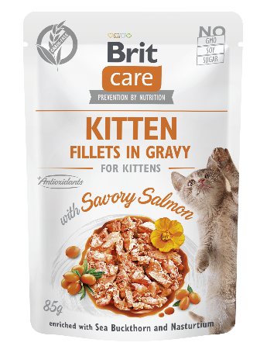
Fillets in Gravy with Savory Salmon Enriched with Sea Buckthorn and Nasturtium.

Complete Superpremium Grain-Free Wet Food for Kittens

- No GMO/soy/sugar

Package: 85 g

Composition: fillets with 85% meat (62% chicken, 15% liver, 8% salmon), lignocellulose, 1% dried sea buckthorn, 0.5% dried nasturtium, calcium carbonate, pea flour.

Feeding guide: The recommended daily allowance is shown in the feeding table but may vary depending on your cat’s age, activity level, and enviroment. Always provide a bowl of fresh water. Serve at room temperature. When serving for increased variety and flavour, be sure to reduce the recommended daily serving size of your cat’s regular food accordingly. Keep in fridge after opening.

Feeding table:
Age of kitten (months) | 2 – 4 | 4 – 6 | 6 – 12
Pouches per day | 1.5 - 2 | 2 – 3 | 3 – 4

Analytical constituents:
crude protein | 7.5 | %
crude fat | 4.0 | %
crude fibre | 0.5 | %
crude ash | 2.2 | %
moisture | 82.0 | %
calcium | 0.2 | %
phosphorus | 0.2 | %
sodium | 0.25 | %
Nutritional additives per 1 kg:
vitamin A (3a672a) | 600 | IU
vitamin D₃ (3a671) | 150 | IU
vitamin E (3a700) | 70 | mg
choline chloride (3a890) | 60 | mg
vitamin B₁ (3a821) | 0.6 | mg
biotin (3a880) | 0.25 | mg
zinc (3b606) | 6 | mg
manganese (3b502) | 1.5 | mg
iron (3b103) | 5 | mg
iodine (3b201) | 0.35 | mg
taurine (3a370) | 600 | mg

Contains EU approved natural antioxidants: tocopherol extracts from vegetable oil (1b306(i)), ascorbyl palmitate (1b304) & rosemary extract.

Keep in a dry and cool place away from direct sunlight. Expiry date 24 months from production date, batch printed on package.

Metabolizable energy: 800 kcal/kg

Producer: VAFO Production s.r.o., Produced for: VAFO PRAHA s.r.o., K Brůdku 94, Chrášťany 252 19, Czech Republic. Registration No.: CZ800175-05, Export No.: CZ31712936

BCC pouches NEW

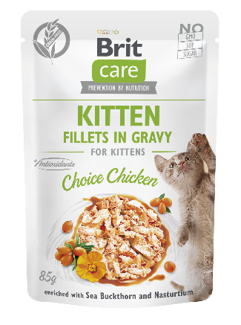
Brit Care Cat Kitten.

Fillets in Gravy Choice Chicken Enriched with Sea Buckthorn and Nasturtium.

Complete Superpremium Grain-Free Wet Food for Kittens

- No GMO/soy/sugar

Package: 85 g

Composition: fillets with 85% meat (70% chicken, 15% liver), lignocellulose, 1% dried sea buckthorn, 0.5% dried nasturtium, calcium carbonate, pea flour.

Feeding guide: The recommended daily allowance is shown in the feeding table but may vary depending on your cat’s age, activity level, and enviroment. Always provide a bowl of fresh water. Serve at room temperature. When serving for increased variety and flavour, be sure to reduce the recommended daily serving size of your cat’s regular food accordingly. Keep in fridge after opening.

Feeding table:
Age of kitten (months) | 2 – 4 | 4 – 6 | 6 – 12
Pouches per day | 1.5 - 2 | 2 – 3 | 3 – 4

Analytical constituents:
crude protein | 7.5 | %
crude fat | 4.0 | %
crude fibre | 0.5 | %
crude ash | 2.2 | %
moisture | 82.0 | %
calcium | 0.2 | %
phosphorus | 0.2 | %
sodium | 0.25 | %
Nutritional additives per 1 kg:
vitamin A (3a672a) | 600 | IU
vitamin D₃ (3a671) | 150 | IU
vitamin E (3a700) | 70 | mg
choline chloride (3a890) | 60 | mg
vitamin B₁ (3a821) | 0.6 | mg
biotin (3a880) | 0.25 | mg
zinc (3b606) | 6 | mg
manganese (3b502) | 1.5 | mg
iron (3b103) | 5 | mg
iodine (3b201) | 0.35 | mg
taurine (3a370) | 600 | mg

Contains EU approved natural antioxidants: tocopherol extracts from vegetable oil (1b306(i)), ascorbyl palmitate (1b304) & rosemary extract.

Keep in a dry and cool place away from direct sunlight. Expiry date 24 months from production date, batch printed on package.

Metabolizable energy: 800 kcal/kg

Producer: VAFO Production s.r.o., Produced for: VAFO PRAHA s.r.o., K Brůdku 94, Chrášťany 252 19, Czech Republic. Registration No.: CZ800175-05, Export No.: CZ31712936

REVISED ITEMS
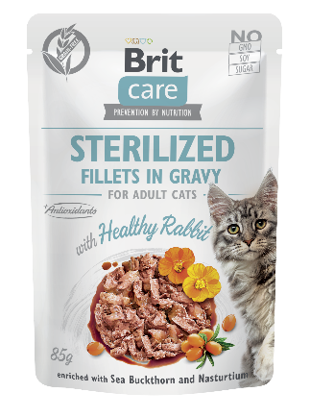
BCC pouches

Brit Care Cat Sterilized.

Fillets in Gravy with Healthy Rabbit Enriched with Sea Buckthorn and Nasturtium.

Complete Superpremium Grain-Free Wet Food for Adult Sterilized Cats

Complete Superpremium Grain-Free Wet Cat Food for Adult Sterilized Cats

- No GMO/soy/sugar
- L-methionine / Urine pH control support

Package: 85 g

Composition: fillets with 85% meat (62% chicken, 15% liver, 8% rabbit), lignocellulose, 1% dried sea buckthorn, 0.5% dried nasturtium, calcium carbonate, pea flour.

Feeding guide: The recommended daily allowance is shown in the feeding table but may vary depending on your cat’s age, activity level, and enviroment. Always provide a bowl of fresh water. Serve at room temperature. When serving for increased variety and flavour, be sure to reduce the recommended daily serving size of your cat’s regular food accordingly. Keep in fridge after opening.

Feeding table:
Weight of cat (kg) | 3 | 4–6 | 6–8
Pouches per day | 2 | 3–4 | 4–6

Analytical constituents:
crude protein | 7.0 | %
crude fat | 3.0 | %
crude fibre | 0.5 | %
crude ash | 2.0 | %
moisture | 82.0 | %
calcium | 0.2 | %
phosphorus | 0.2 | %
sodium | 0.25 | %
Nutritional additives per 1 kg:
vitamin A (3a672a) | 400 | IU
vitamin D₃ (3a671) | 100 | IU
vitamin E (3a700) | 50 | mg
choline chloride (3a890) | 60 | mg
vitamin B₁ (3a821) | 0.3 | mg
biotin (3a880) | 0.1 | mg
zinc (3b606) | 3.5 | mg
manganese (3b502) | 0.8 | mg
iron (3b103) | 2.8 | mg
iodine (3b201) | 0.2 | mg
taurine (3a370) | 500 | mg
L-methionine (3c305) | 2 000 | mg

Contains natural antioxidants: tocopherol extracts from vegetable oil (1b306(i)), ascorbyl palmitate (1b304) & rosemary extract.

Keep in a dry and cool place away from direct sunlight. Expiry date 24 months from production date, batch printed on package.

Metabolizable energy: 755 kcal/kg

Producer: VAFO Production s.r.o., Produced for: VAFO PRAHA s.r.o., K Brůdku 94, Chrášťany 252 19, Czech Republic. Registration No.: CZ800175-05, Export No.: CZ31712936

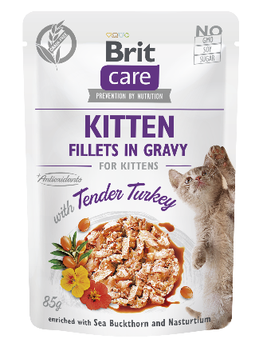
BCC pouches

Brit Care Cat Kitten.

Fillets in Gravy with Tender Turkey Enriched with Sea Buckthorn and Nasturtium.

Complete Superpremium Grain-Free Wet Food for Kittens.

- No GMO/soy/sugar

Package: 85 g

Composition: fillets with 85% meat (62% chicken, 15% liver, 8% turkey), lignocellulose, 1% dried sea buckthorn, 0.5% dried nasturtium, calcium carbonate, pea flour.

Feeding guide: The recommended daily allowance is shown in the feeding table but may vary depending on your cat’s age, activity level, and enviroment. Always provide a bowl of fresh water. Serve at room temperature. When serving for increased variety and flavour, be sure to reduce the recommended daily serving size of your cat’s regular food accordingly. Keep in fridge after opening.

Feeding table:
Age of kitten (months) | 2 – 4 | 4 – 6 | 6 – 12
Pouches per day | 1.5 - 2 | 2 – 3 | 3 – 4

Analytical constituents:
crude protein | 7.5 | %
crude fat | 4.0 | %
crude fibre | 0.5 | %
crude ash | 2.1 | %
moisture | 82.0 | %
calcium | 0.2 | %
phosphorus | 0.2 | %
sodium | 0.25 | %
Nutritional additives per 1 kg:
vitamin A (3a672a) | 600 | IU
vitamin D₃ (3a671) | 150 | IU
vitamin E (3a700) | 70 | mg
choline chloride (3a890) | 60 | mg
vitamin B₁ (3a821) | 0.6 | mg
biotin (3a880) | 0.25 | mg
zinc (3b606) | 6 | mg
manganese (3b502) | 1.5 | mg
iron (3b103) | 5 | mg
iodine (3b201) | 0.35 | mg
taurine (3a370) | 600 | mg

Contains natural antioxidants: tocopherol extracts from vegetable oil (1b306(i)), ascorbyl palmitate (1b304) & rosemary extract.

Keep in a dry and cool place away from direct sunlight. Expiry date 24 months from production date, batch printed on package.

Metabolizable energy: 805 Kcal/kg

Producer: VAFO Production s.r.o., Produced for: VAFO PRAHA s.r.o., K Brůdku 94, Chrášťany 252 19, Czech Republic. Registration No.: CZ800175-05, Export No.: CZ31712936

